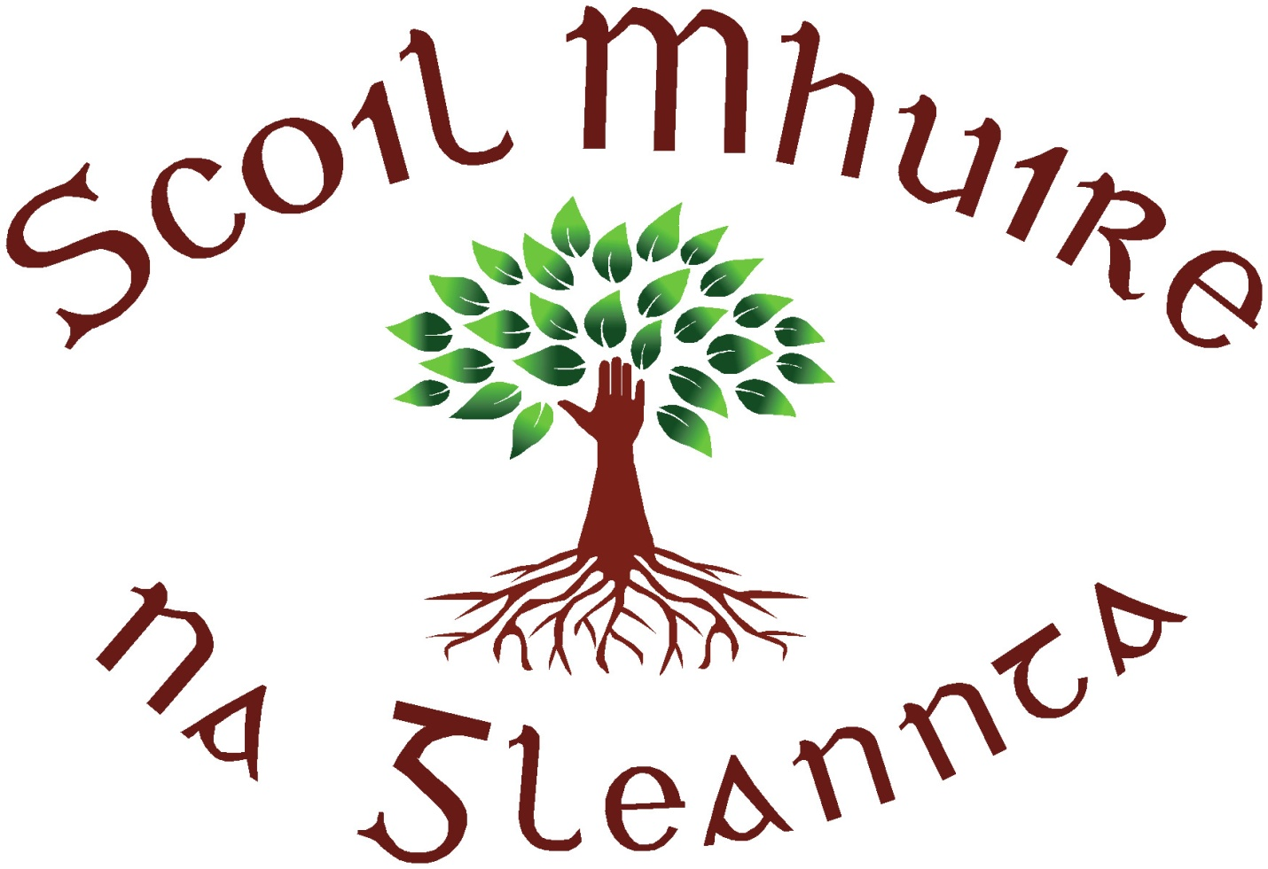
Scoil Mhuire N.S., Glenties, Co. Donegal.
Roll No. 19912 B
Tel. No. / Fax – 0749551521.
Mobile – 087 0924958
E-mail – glentiesns@gmail.com
Principal – Miss Tracey Whyte

28th August 2020
Dear Parents
We are delighted our school is now ready to open on Monday the 31st of August in line with the Department of Education guidelines.
I would like to introduce myself, Miss Tracey Whyte as the new Acting Principal while Ms. Rodgers is on maternity leave. I am delighted to join such a wonderful school with such dedicated and hardworking staff. I have heard that all the pupils are simply fantastic. I look forward to meeting you on Monday. Thank you to everyone for you support and well wishes and do not hesitate to phone or make an appointment if you have any queries.
I would like to remind Parent and Carers to not congregate around the school for safety reasons. Ring the school phone number if you need to meet with a staff member.
Do not send your child to school if they are displaying any signs of Covid-19.
- a fever (high temperature - 38 degrees Celsius or above)
- a cough - this can be any kind of cough, not just dry
- shortness of breath or breathing difficulties
- loss or change to your sense of smell or taste – this means you've noticed you cannot smell or taste anything, or things smell or taste different to normal
Please consult the HSE website for further information.
Please continue to keep an eye on the school website and most importantly the section Return to school. This includes government videos and advice and will be updated when we hear anything from the Department of Education.
----------------------------------------------------------------------------------------------------------------------------------------------------------------------------------------------------------
In our school we will are following all guidelines outlined by the department and we will adapt to the needs of our pupils and do our utmost to ensure a safe school environment for all. To do this we ask that.
- Take uniforms off straight away after school
- Bring as little in bags as possible if your teacher has your copies only bring one
- Minimum stationary in pencil cases and ideally labelled
- Coats will be hung on the back of chairs
- Masks are not mandatory but if a pupils wants to wear one they can
- Some staff may be wearing masks or shields
IMPORTANT
On the first day we will be sending out a letter to get contact details of parents and one other. Please ensure you fill this in as due to the Covid-19 guidelines it is necessary be able to contact you.

Department of Education, Reminder to anyone attending school who has travelled abroad:
Government policy, which is based on official public health advice, continues to advise against non-essential travel overseas for everyone.
It is a requirement for anyone coming into Ireland, from locations other than those with a rating of ‘normal precautions’ (“green”), to restrict their movements for 14 days, and this includes school staff, parents and children or other students coming from abroad to attend school in Ireland. Restricting your movements means staying indoors in one location and avoiding contact with other people and social situations as much as possible.

With Kindest Regards

______________________
Miss Tracey Whyte
Acting Principal

