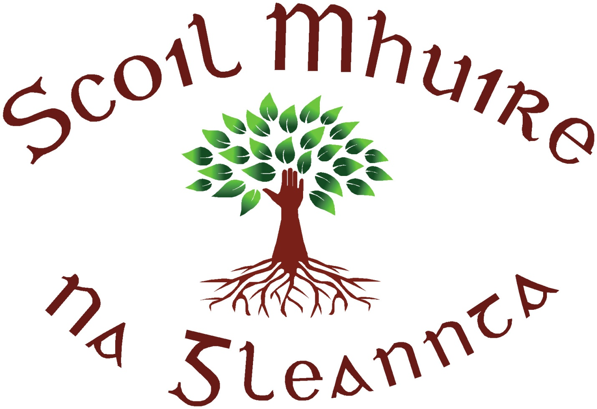
Scoil Mhuire N.S., Glenties, Co. Donegal.
Roll No. 19912 B
Tel. No. / Fax – 0749551521.
Mobile – 087 0924958
E-mail – glentiesns@gmail.com

5th May 2020
Dear Parents/Guardians
You will have got my message that this was going to be a short week of home schooling. It was felt that as we would have officially been closed Monday and Tuesday, we would carry that through to online learning also. I hope you enjoyed the long weekend and the beautiful weather we have had.
You will now find work uploaded to the website. Again, if you require any work printed off please just let me know. Teachers have asked that each child submit one piece of work towards the end of each week, this is to allow the teacher engage with your child’s work and provide praise and encouragement. If you are experiencing any difficulty with your child’s learning or have any queries all teachers are available via email and are more than willing to discuss this with you.
Teachers will be permitted to enter the school on the 18th May therefore we will be in discussion regarding getting additional hard copies of books to you and relevant materials. I will be in contact with you closer to the time regarding this.
Following on from the latest recommendations regarding returning to school, it has become apparent that we will not be returning to school as a unit until the new school year. While we have to respect the decisions that are made, in our best interest, I am aware that this creates difficulties and also worries for parents. Please be assured that while teachers are making work available for your child, there is no onus on you to do everything that is being given. You must only do what your situation allows. When we return to school we will slowly take our time to pick ourselves up, get back on our feet and get into the teaching and learning zone again. We will ensure that no child is at a disadvantage due to the school closure.
Of course one group of children that this announcement has a big impact on is our current 6th class. They have now effectively finished their primary school learning at school, but it can still take place at home. Please use these few weeks to encourage your child to submit work to the class teacher - they will need all the encouragement and reassurement they can get in these strange times.
I will be in contact with the secondary school regarding a smooth transition for the 6th class pupils and, in consultation with Ms Mc Gill and Ms Bonner, we will ensure that our 6th class get a special send off. This will all be carried out in line with guidelines and we will be in touch with you again regarding this.
All teachers are available should you wish to make contact with them and any general queries please do not hesitate to contact me on glentiesns@gmail.com or 087 0924958.
Take care and look after yourselves,
Cróna Rodgers
Cróna Rodgers
Principal

