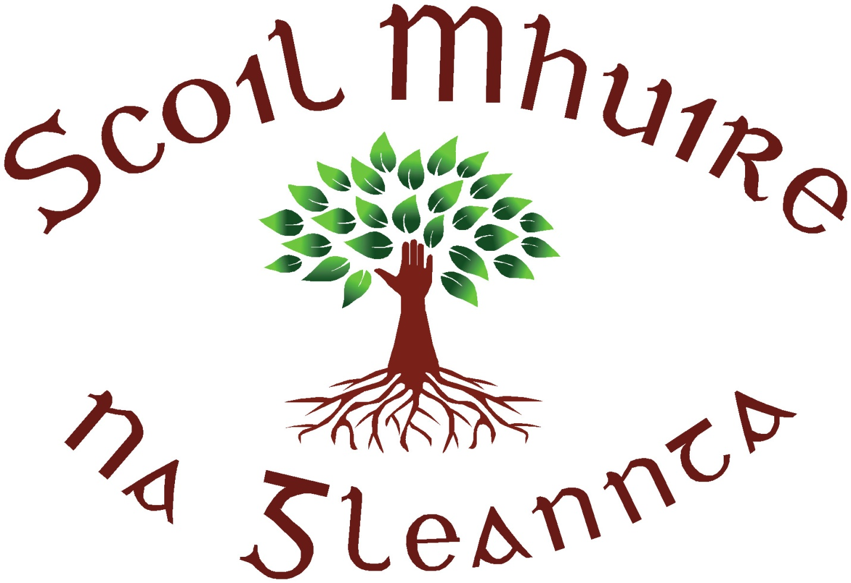
Scoil Mhuire N.S., Glenties, Co. Donegal.
Roll No. 19912 B
Tel. No. / Fax – 0749551521.
Mobile – 087 0924958
E-mail – glentiesns@gmail.com

Incoming Junior Infants
22nd June 2021
Dear Parents/Guardians

We are really looking forward to welcoming your child into our school community on the 30th August.
There are a few things which I want to bring to your attention. Some of you may already have children in the school and are familiar with these while others are starting a completely new chapter with their child!
- On your child’s first day of school, we realise how important a day this is for both you and your child. While keeping in line with guidelines and advice, but also understanding the ‘first day of school’ emotions we allow for one parent/guardian to accompany each child into the classroom. Of course your child may be more than happy to skip in by him/herself and by all means let them!
Should you wish to come in with your child, we ask that you come directly in the front door and down to the classroom. Please then exit via the back door and around by the back of the school. School staff will be about to guide you! Ms Kerrigan will ensure that each child gets a ‘first day at school’ photo taken in the classroom so there is no need for photos inside.
- For the 1st two weeks, to allow the children time to settle in, all Junior Infants go home at 12pm. They will be brought to the top gate by Ms Kerrigan where you can collect them.
- There will be a meeting in September/October to outline the Junior Infant curriculum, school environment and to answer any questions you may have.
- Scoil Mhuire operates a School Lunches programme which is fully funded by the Department of Social Protection. Further information will be provided on this in September if you wish to avail of it. Until you have been notified, please send in a small snack and a lunch with your child. As a school we aim to maintain a healthy eating policy so please keep this in mind when sending in lunches.
- A lot of information relating to the school is available on our website www.scoilmhuireglenties.com – please have a look!
If you have any queries over the summer you can contact me at glentiesns@gmail.com or your child’s class teacher, Ms Kerrigan at lelia@scoilmhuireglenties.com.
Have a lovely summer and we will see you all on Monday 30th August!
_____________________

Ms Rodgers
Principal

