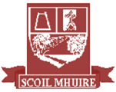

**Scoil Mhuire**

**Newsletter Summer 2019**



We have reached the end of an extremely busy and productive school year. We have had great success and fun throughout the year – tours, quizzes, football, athletics, swimming, dancing, singing, arts, crafts, computers, publishing books to name but a few, It’s hard to find time to work but we’ve managed it!

We bid farewell to our 6th class who have been a great group to have and we wish them all the best in the Comp. We look forward to welcoming our new Junior Infants in September and also new families who will be joining us over the summer.

I thank the staff of Scoil Mhuire who have worked hard all year and wish them a happy summer.  Our Parents’ Association have been busy throughout the year and while we will be sad to see some members retiring we look forward to welcoming new members on board in September.

We have been lucky to have such a proactive and committed Board of Management. Their tenure will come to an end in September and I thank them for all the support they have given me, the staff, the children and the school community.

Master Mc Cann will be retiring from Scoil Mhuire at the end of the summer. I thank him for the service he has given the school and wish him all the best in his retirement. I also thank Ms Boyle who has subbed while Master Mc Cann was off. We were fortunate to have such a dedicated teacher and wish her the best in her future plans.

Have a lovely summer, keep safe and we look forward to seeing you all in September!

Cróna Rodgers

In this newsletter:

* Cumann na mBunscol County Champions
* Trot on Tuesday Green School Initiative
* School Tours to Lurgybrack, Bundoran & Letterkenny
* History, Streetwise and Designers Workshops
* Visits from the Fire Brigade and the Gardaí
* Book Fair and *We Are Writers*
* Sports – Rounders, Athletics, Active Schools Week

...and much, much more!

**Glenties**

**Farewell to 6th Class**

It’s come to that time of the year again where we must sadly say goodbye to a wonderful group of boys and girls. The 6th Class have been great role models to our younger children in Scoil Mhuire and we have fantastic memories of them from their time with us. We wish them all the very best of luck in their new chapter as they enter The Comp in September. We would also like to wish Riaghan Doherty McHugh all the best in her new home and the new school she will be joining in September! We will all miss you in Scoil Mhuire!

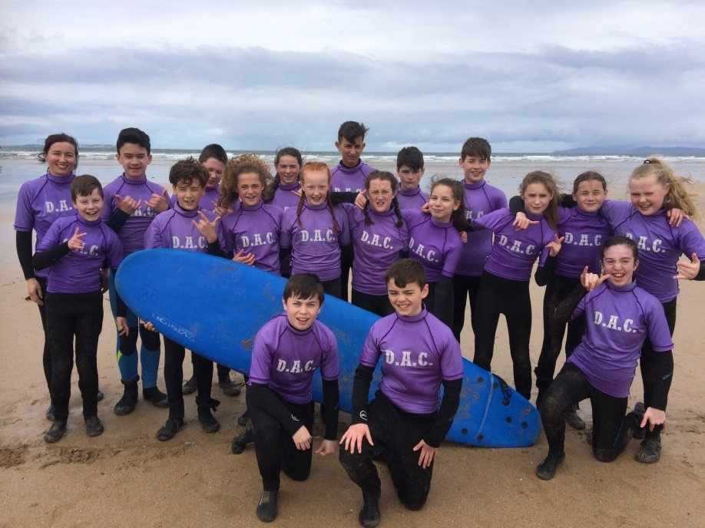

**Trot on Tuesday**

Congratulations to all the pupils and staff who are making a huge effort to trot to school on Tuesdays. We are really making a huge difference to our environment. It may seem a small thing to do but if everyone makes an effort we can reduce carbon emissions, improve our air quality and all the while we are talking and chatting to each other. Congratulations to 2nd and 3rd class as they had the highest percentage of pupils walking in May. Let's see who tops the poll for June!!

**Extreme Activities**

On Friday the 7th of June, the 4th and 5th Class pupils went to Letterkenny Extreme Centre for our school tour. We did The Ultimate Mud Run, waterslide, tug of war, army obstacle course, target practice and a nature trail. All of these activities were great fun and we all loved it! Afterwards, we went to Arena 7 for our lunch and then to Ballymacool Park for an hour of play. We really enjoyed our day!

By Cian Gildea, Bethany Gilroy & Erin Bonner

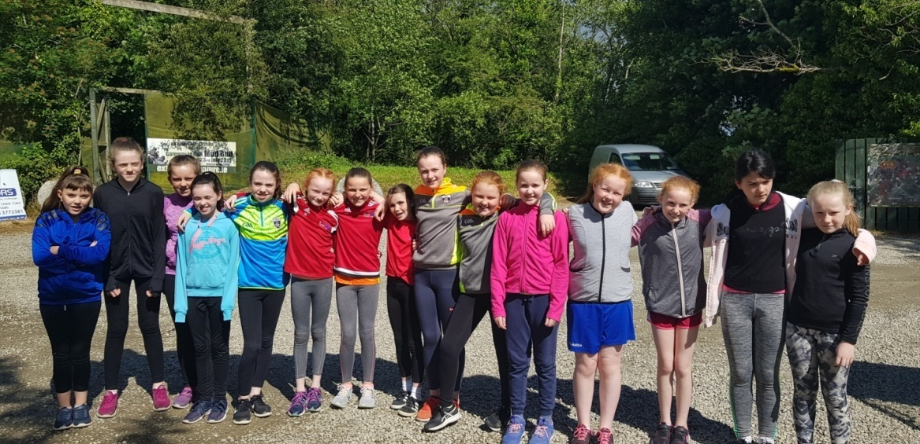

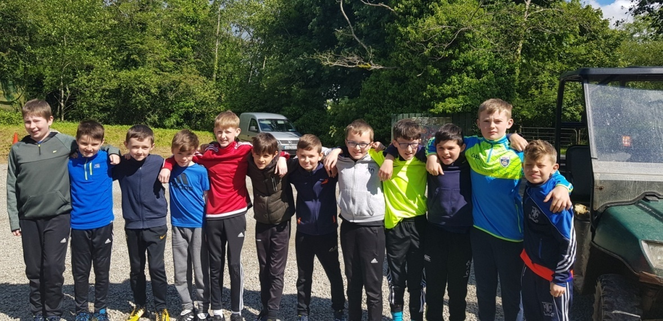

**Fire Safety**

Thanks to Hugo Doherty and Stephen McDermott from the Glenties Fire Brigade who visited the 2nd and 3rd Classes on the 30th May to remind us all about the dangers of fire. They also gave us some great tips to take home with us to keep our homes safer and to prevent fires from starting.

**Friends for Life**

This year 4th & 5th class pupils participated in Friends for Life, which is a programme that helps people to grow happier and calmer. 5th Class did the activities with Ms. Bonner and 4th Class with Ms. Rodgers. It was a time when we did meditation, pizza massage, milkshake breathing, brain exercise and many more relaxing things. We had great fun doing all of these exercises! Sometimes we would lie on the ground and listen to ‘Smiling Mind’ which is an Australian app. The pizza massage is when we gave another person a massage on the back and pretended that we were making a pizza. Milkshake breathing is an activity where we got water and a straw and breathed in through our noses and out through our mouths, slowly making bubbles. We loved it and had great fun and can’t wait until next year to do it again.

By Bethany Gilroy & Erin Bonner.

**Century Complex**

On Tuesday the 11th of June 2nd & 3rd Class went to Century Cinema and Century Play in Letterkenny on our school tour. We sang songs on the journey and at the cinema we watched *The Secret Life of Pets II* which was great. The film was about pet cats and dogs living in a city that save a tiger that is being treated poorly in a circus. We also enjoyed popcorn and a drink while watching the movie! After the film we went to Century Play which is alongside the cinema where we played in the ball pit, the slides and we went through tunnels and ran about. We enjoyed a meal afterwards before heading home. We had a wonderful day!

By Áine Bonner and Sara Byrne

**Book Fair 2019**

Our annual Book fair was a great success again this year. A total of €863 was raised. The school receives €580 worth of free books as a result of the Book Fair. These books will be used to enhance the school library and provide additional reading material for your child. Thank you so much for your generosity. We would also like to thank the 6th class who were assisting at the Fair. They were a wonderful help and they made sure everything ran smoothly. Go raibh maith agaibh.

**Little Gardeners**

Our Junior and senior infants have been busy growing their own herbs and vegetables. Charlie and Neil brought in lidl seed pots and they all sowed and nurtured their own plant. Little green fingers were all busy and we now have a productive vegetable patch!

**Garda Visit**

On the 6th of June we were visited by the local Gardaí. They explained the importance of having a booster seat when you are below the height of 150 centimetres and that it is always safer to sit in the back seat if possible. They also discussed stranger danger and reminded us to tell a trusted adult if something happens to you. They warned us not to give away our name or address if chatting or messaging online. At the end they let us try on the Garda outfits!

By Anton Campbell & Elijah Sangha

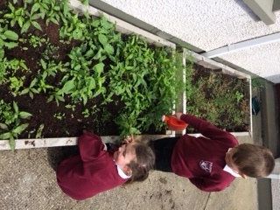

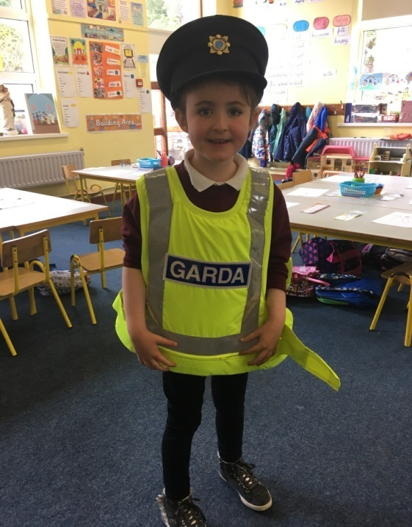

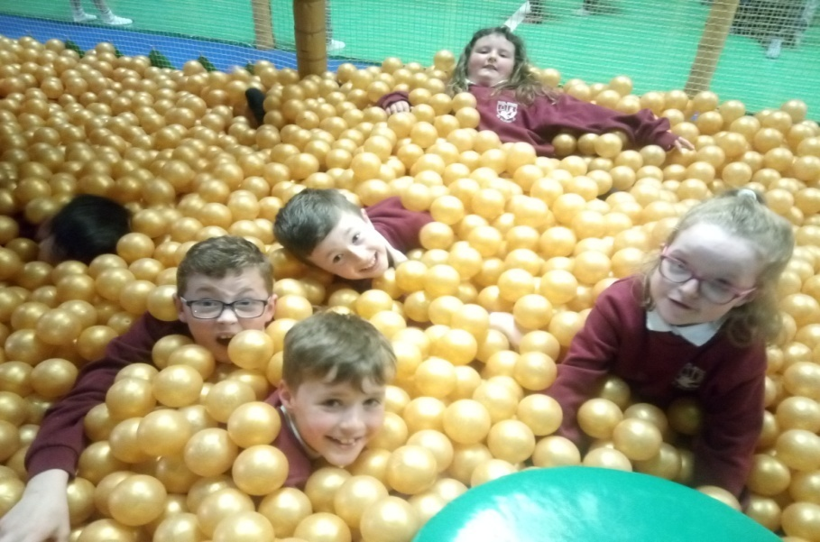

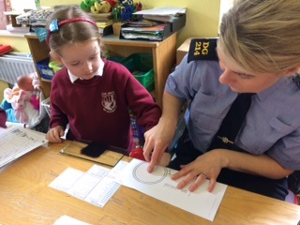

**Streetwise Workshop**

On the 27th and 30th of May 6th Class had a ‘Streetwise Workshop’ on alcohol awareness. We played some games and talked about how much alcohol is safe to consume. They told us stories about people being pressurised by peers into taking cigarettes or alcohol and advised us to make up our own minds if that happens to us. You need one hour to get a unit of alcohol out of your system. People react in all different ways to alcohol and it does not suit everybody. The workshop was really helpful and we learned a lot.

By Anton Campbell & Elijah Sangha

**History Workshop**

On 21st May the 5th and 6th Classes enjoyed a history workshop by Ciaran Brogan. It was centred around the story of the Spanish Armada but we also learned a lot about wars and battles that took place in our local area long ago.

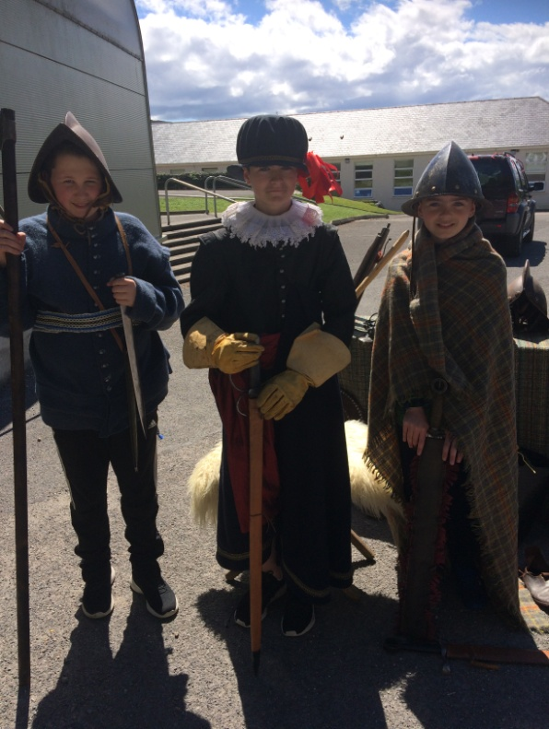

**Lurgybrack Farm**

The boys and girls in Junior Infants, Senior Infants and 1st Class had a wonderful day at Lurgybrack Farm for their school tour recently. They saw a lot of farm animals and even got a ride around the grounds on a tractor! They also enjoyed some play time in the activity park there. The rain didn’t dampen their spirits one bit as everyone had a fabulous time!

**Spelling Bee**

Congratulations to Orla Molloy who won the annual Scoil Mhuire Spelling Bee competition earlier this year. Orla came through as the top speller from the 5th and 6th Class boys and girls after a long but enjoyable tussle! She represented the school at the County Finals of the Donegal Spelling Bee in Drumkeen NS in May. Well done, Orla!

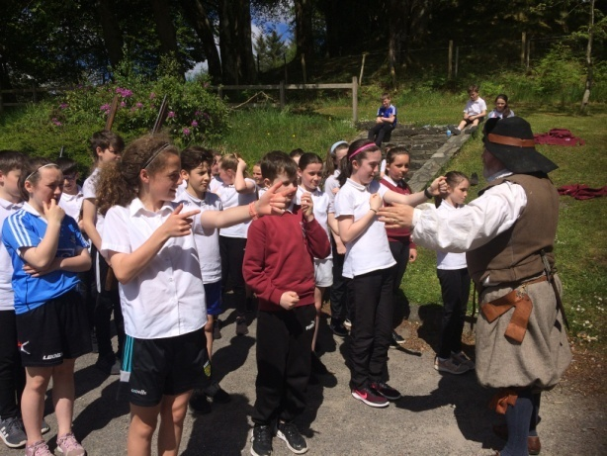

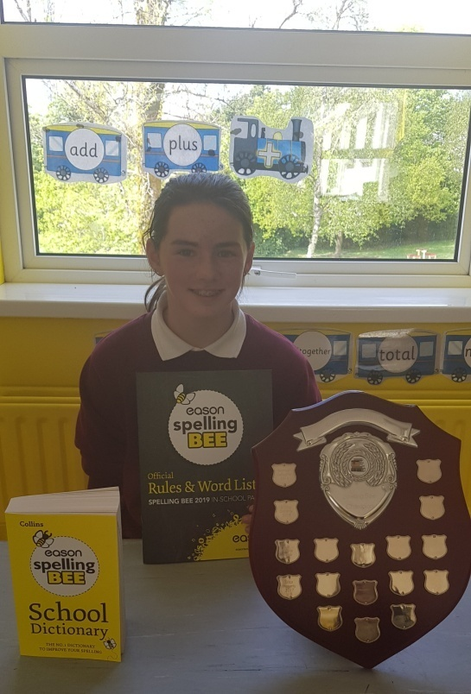

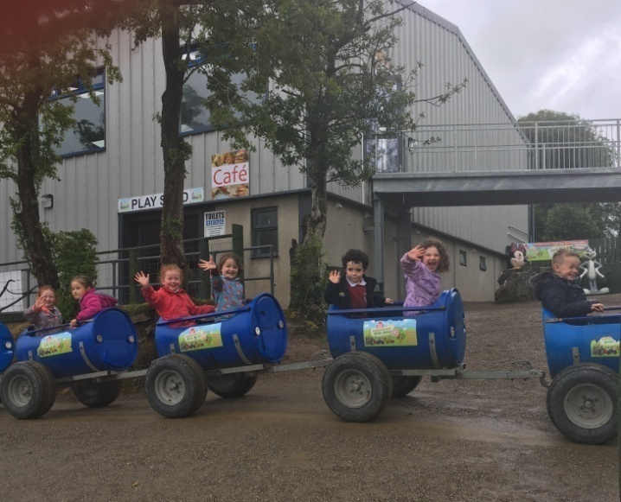

**Dates for the Diary**

Don’t forget to check out next year’s dates for closure on the next page!

**Cash for Clobber**

A total of 152 bags were collected in our recent Cash for Clobber fundraiser. Thank you to everyone who supported!

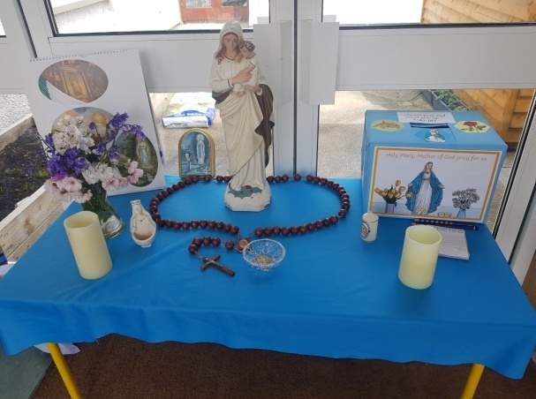

**May Altar**

During the month of May we remember Mary in a special way. In Scoil Mhuire we set up a May altar with a prayer box asking our Blessed Mother to present our prayer intentions to God. Our school Mass on 21st June was offered for all of the prayers we placed in our prayer box. 'She intercedes for us most powerfully by her motherly prayers, obtaining what she desires. She cannot be disappointed.' Pope Plus IX

**We Are Writers**

This is a sample of creative writing that can be found in our *We are Writers* book. This book is available to buy in Scoil Mhuire. We want you to sit back and enjoy this wonderful compilation of poetry, story and tributes which have been written by the pupils in the school. They really are wonderful.

**The Abandoned House**

The abandoned house, number 33, on Witches Avenue always intrigued me. It was now time to take a visit. My friend came too. As we walked up the crooked path we saw heavy grey clouds looming above us. We came to the end of the path and looked up. There was a wooden door with a rusty handle and a skull popping out at the front. I raised my hand and turned the handle. I pushed the door open and we walked in. There were cobwebs everywhere and the wooden floor creaked with every step we took. We opened another door and went into what looked like the kitchen. My knees were trembling, my hands quivered and the silence in the house paralysed me. We kept going on, frightened to see what was next. Then suddenly the door slammed shut. We both jumped, a rancid odour filled our nostrils. After the door had slammed shut I saw a door. I opened it and when we saw what was in I felt sweat pouring down my forehead. We both looked at each other and let out a shriek. Were we going to venture in? Then we stepped forward and took a deep breath....the enormity of what happened hit me.

Shauna Molloy (5th Class)

**Pretty Plants**

Senior Infants & First Class have been planting broad beans and learning about what a plant needs in order to grow. They're growing really quickly in our warm classroom. Our tallest plant is 43cm tall!

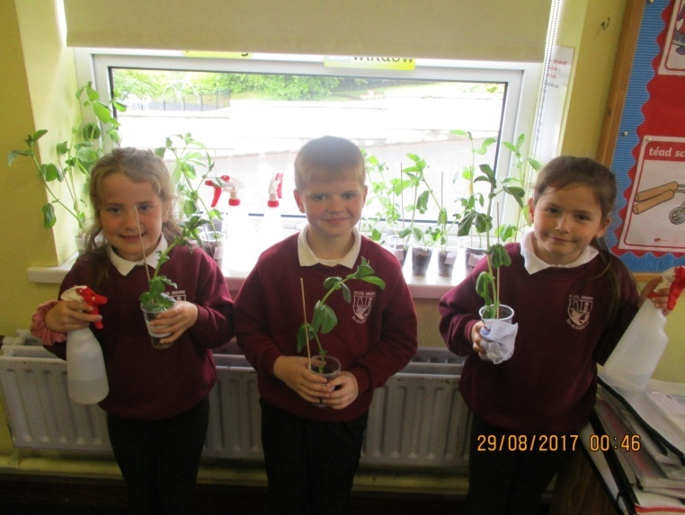

**Aistear**

Senior Infants and 1st Class have been having fun learning about the farm as part of their Aistear learning. The children were imagining what life would be like in a farm workshop and their visit to Lurgybrack Farm gave them a real flavour of what work would be involved.

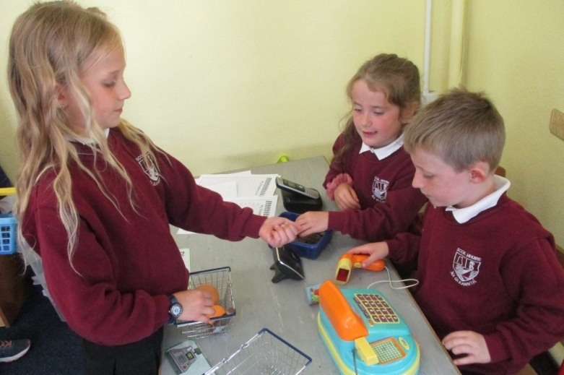

**Clean-up Day**

On Monday 17th June all the boys and girls in Scoil Mhuire took part in a clean-up of our community. We used litter-grabbers, refuse sacks, disposable gloves and high-viz jackets to keep ourselves safe. We gathered rubbish from the approaching roads and parks around Glenties and we are happy to report that our community is looking splendid as a result of our efforts! Well done everyone!

**School Closures 2019/2020:**

**School re-opens Thursday 29th August**

**Closed Thursday 12th September (Harvest Fair Day)**

**Hallowe’en Mid-Term Break**

Closing on Friday 25th October / re-opening Monday 4th November

**Christmas Break**

Closing on Friday 20th December / Re-opening Monday 6th January

**Spring Mid-Term Break**

Closing on Thursday 20th & Friday 21st February

**Easter Break**

Closing on Friday 3rd April / Re-opening Monday 20th April.

**Other Closures**

Closed on 16th & 17th March

Closed on 4th & 5th May

Closed on 1st & 2nd June

**Summer Holidays**

School will close on Friday 26th June 2020

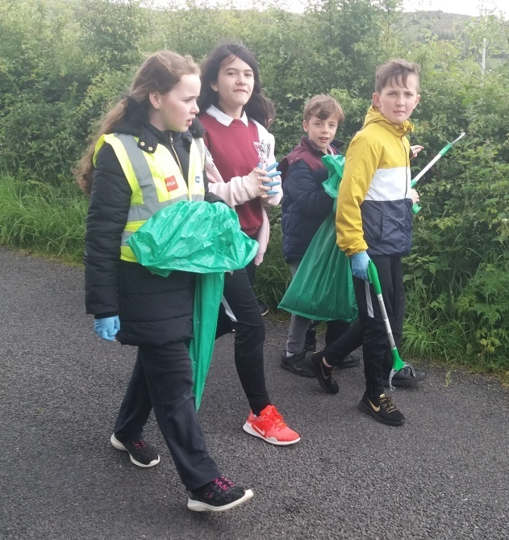

**Cursive Handwriters**

First Class were working on their beautiful cursive handwriting while writing about the school tour. They are fantastic writers!

**First Holy Communions**

2nd class made their First Holy Communion on Saturday 11th May. They prepared very hard all year for this special day and they all had a wonderful day with their families and friends. They looked fantastic and did their jobs so well during the Mass. Congratulations to all of 2nd class!

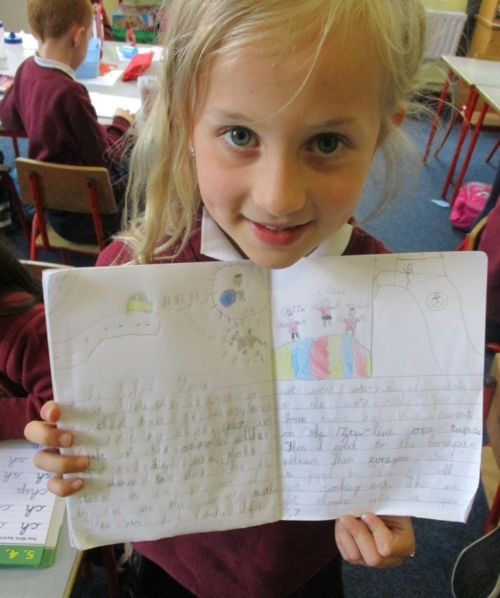

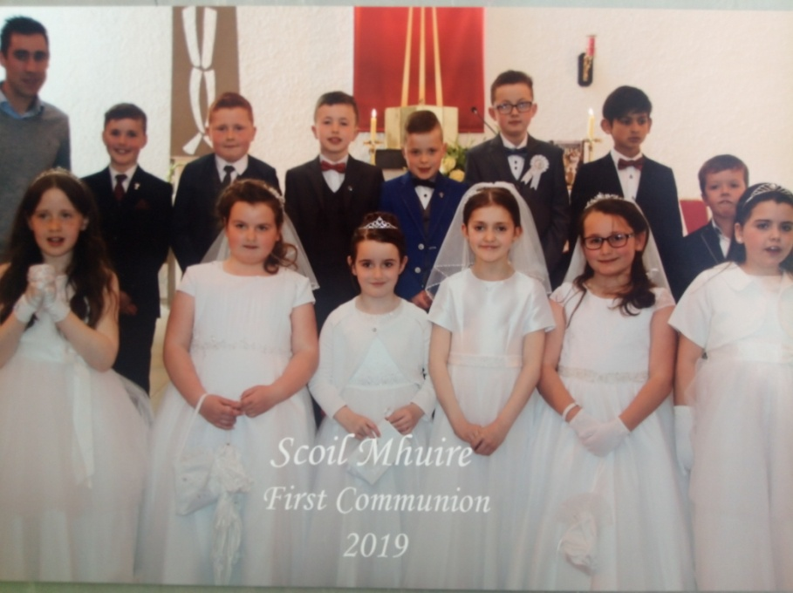

**Designers Workshop**

On 20th June Anthony Carr kindly visited the 6th Class to give a workshop on design and how it can help with everyday life. We learned that when designing a product you have to locate a need for something. It must then be designed to appeal to a certain demographic, such as disabled people. You then create a prototype and finally start production. We then deigned our products in groups and drew them out. It was fun and we learnt a lot about design. Many thanks to Anthony for coming in to teach us!

**Buddy Bench**

Many thanks to Joe Gavigan who constructed a beautiful Buddy Bench for the school playground. It’s proving very popular among the boys and girls from Junior Infants right up to 6th Class!

**Tree Planting**

The 6th Class enjoyed a nature walk to Glenmacannive where Martin Regan and a representative from Coillte spoke about the landscape and the trees in our locality. Each child was given an oak tree to plant and hopefully they will get to see their tree flourish in years to come!



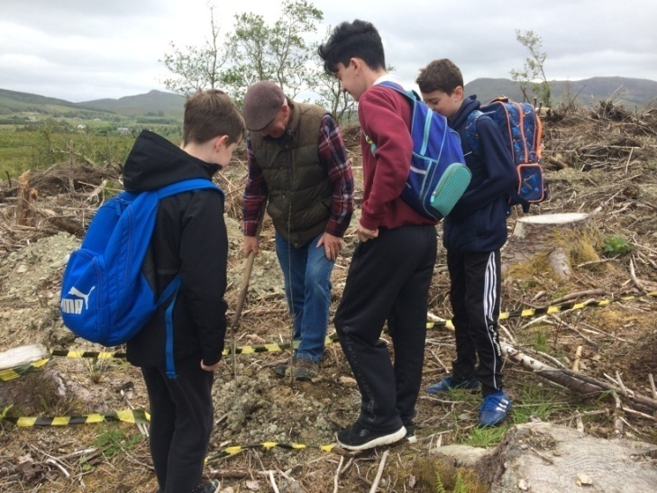

**Concert**

The school was treated to a wonderful end of year concert from the 4th, 5th and 6th Class boys and girls. We enjoyed a variety of singing, recorder, violin, guitar, piano and keyboard! What talented children we have in our community! Many thanks to Ms. Connole for preparing the boys and girls!

**6th Class Tour**

The 6th Class enjoyed a memorable school tour to Bundoran at the end of their year. They went surfing and body-boarding in the Atlantic and went rock climbing at the Donegal Adventure Centre. They also went to KFC before catching a film in the Bundoran cinema. The word back was that it was “best school tour ever!”

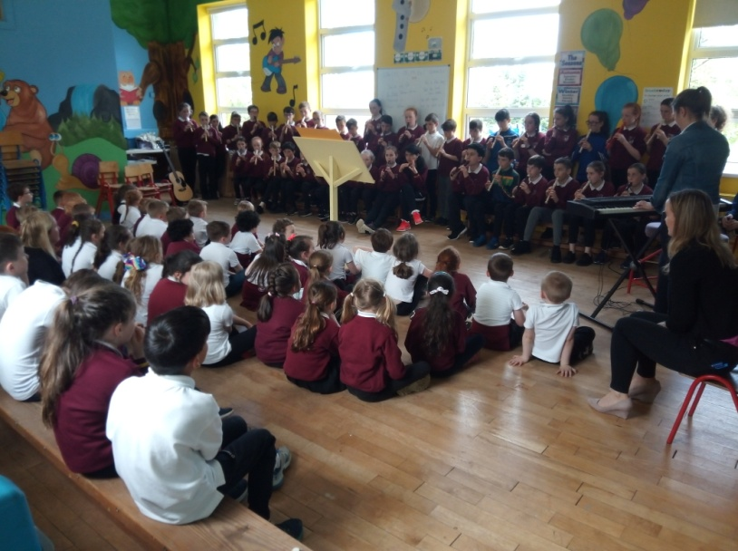

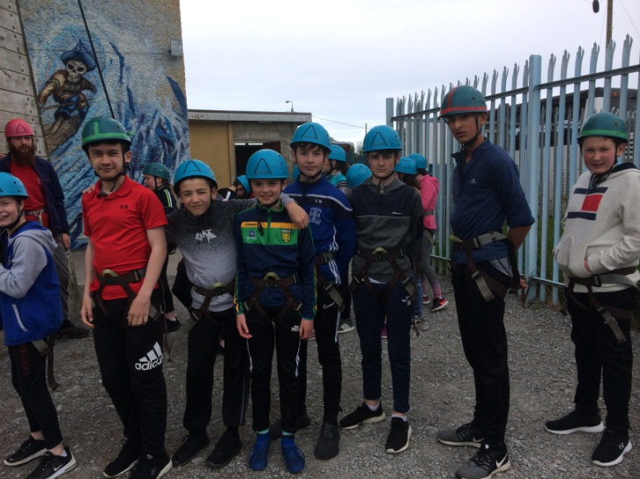

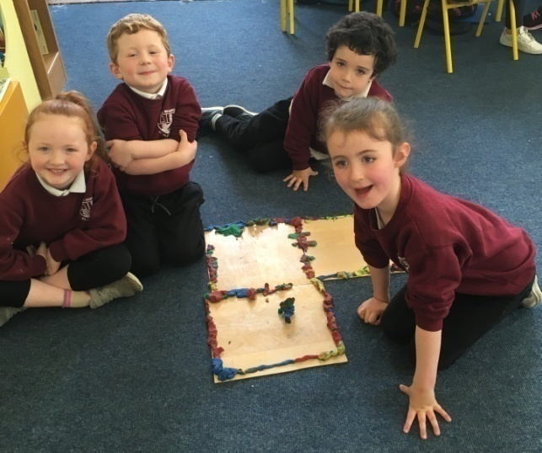

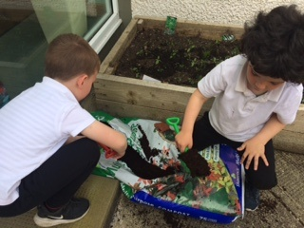

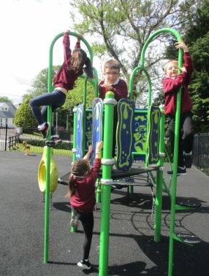

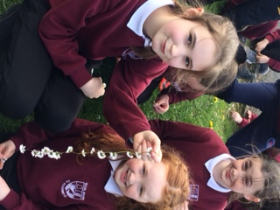

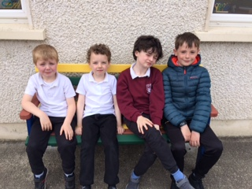

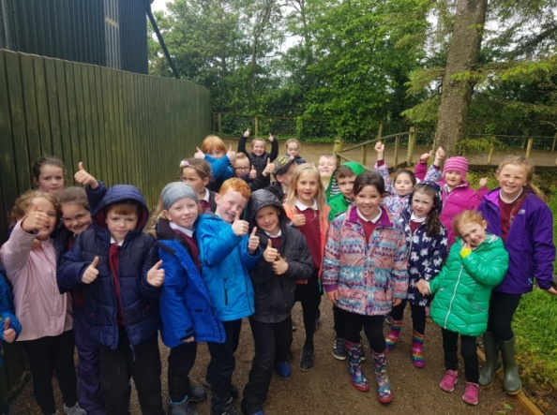

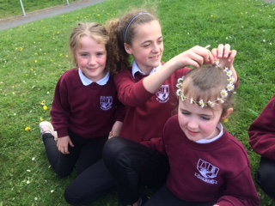

**Active Schools Week 2019**

On Monday 20th of May, the first day of Active Schools Week, Dáithí Roberts came into the school and taught us the basic rules of hurling and camogie. We learnt how to hold the hurl stick properly and how to hit and block the sliotar. On the Tuesday we did Basketball with David Tierney. David comes into our school often to teach us basketball skills. We played lots of games and did drills with him such as dribble survivor, knockout and the line game. On Wednesday Mary O’Callaghan came into the school and did Rinka with us. We learned how to do a front and back roll. The whole class then took part in a long jump competition. Finally on the Thursday we had a Sports Day practice with Mr. Regan including hurdles, relay race, head-to-head race and sprint race. Throughout the week we spent a lot of time outside on our feet and the 2nd and 3rd Class even demonstrated their great teamwork by completing a Treasure Hunt around the school grounds. We had a great week and enjoyed all the activities!

By Cathy Browne, Lara Lynch & Keira McLoone

**Basketball**

Glenfin, Fintown and Scoil Mhuire participated in a basketball tournament earlier this term in the Comprehensive School gym. The students had to be from 3rd Class upwards. The children from all the schools were split up into six teams with ten players on each team. Five were on in the first half and the second five on the second half. The rules were pretty simple - you score and you win and you make it to the next round! Fouls and frees were included. One out of the six teams in each school made it to the semi-finals. Glenties defeated Glenfin in the semi-final but Fintown won the final to win the league. Congratulations Fintown! This tournament was organised by Miss O’Brien who was teaching in our school earlier in the year.

We would also like to thank David Tierney who has been visiting the school regularly this year to take all the classes for basketball lessons. We have picked up so many new skills and techniques and now have a good grasp of the rules of the game and how to play it. Every boy and girl really loves playing the game! Thank you, David!

By Conan Brannigan, Danny Brown and Tristan Buchanan.

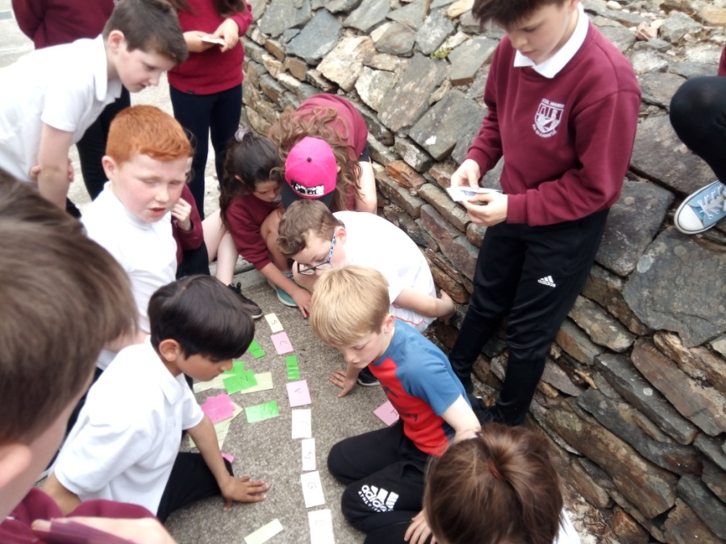

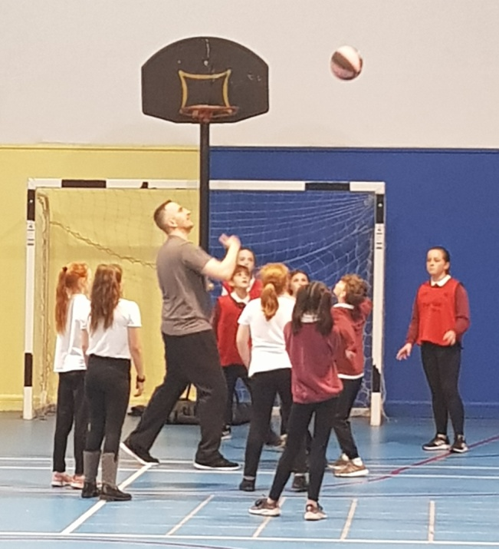

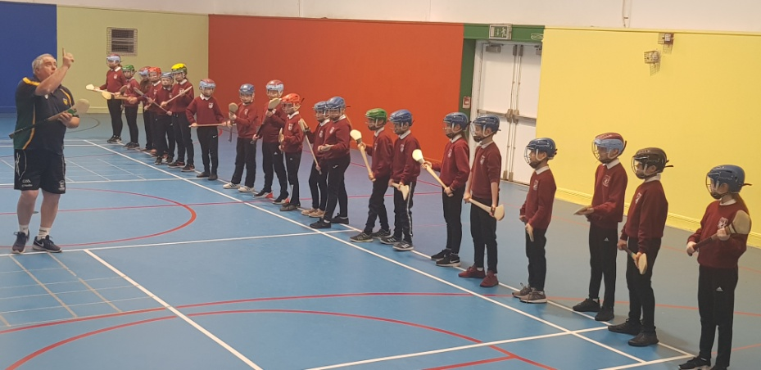

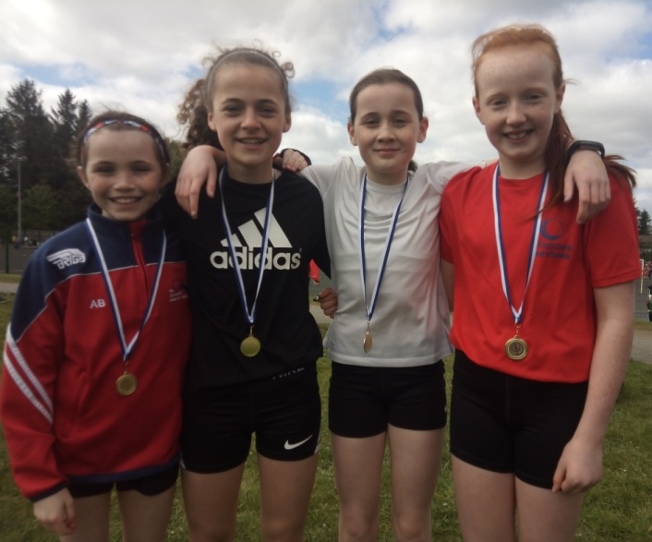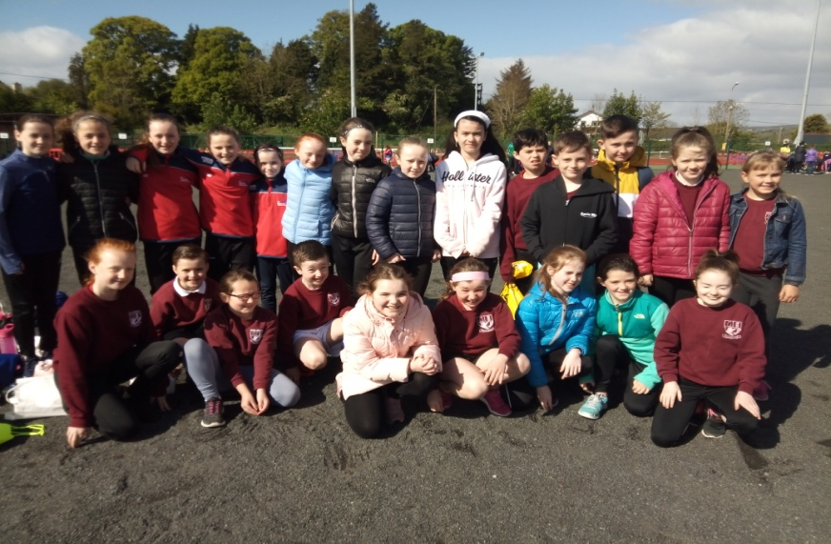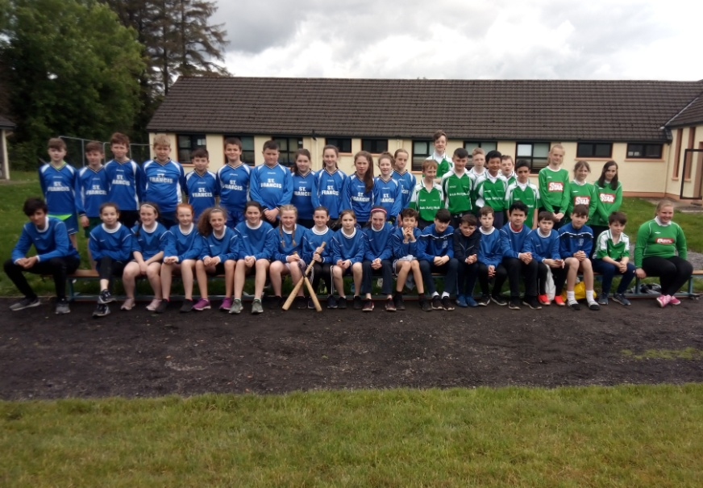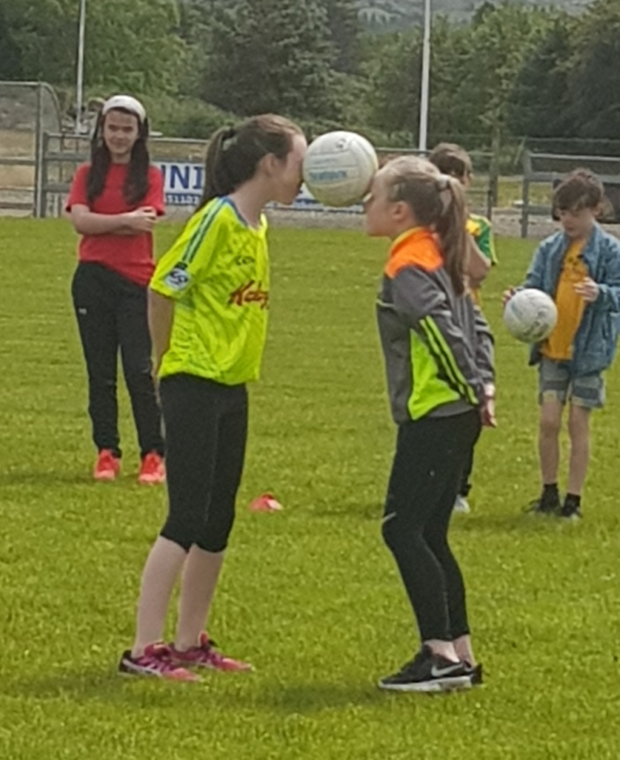

**Athletics**

On Friday the 3rd of May the pupils from Scoil Mhuire took part in an athletics competition in Donegal Town hosted by Tír Chonaill AC. The bus left the school at 9:30am for the competition to start at 10:30am.Twenty four pupils from the school took part in this competition and each athlete performed very well. The school took home a remarkable total of twenty two medals! Our girls relay team took home a gold medal and the boys just missed out finishing 4th place in the race. Well done to everyone who took part and we hope they do just as well next year!

By Cora Doherty & Eve Boyle Carr

**Rounders**

On the 4th of June 6th Class participated in a rounders competition in St. Francis’s NS, Barnesmore. There were 9 players on a team with 3 subs. One team batted while the other team had fielders who tried to catch the ball. Unfortunately we were put out in the first round by St. Francis’s N.S. We played quite well, however, and really enjoyed the day

**Sports Day 2019**

We held our annual Sports Day events on Friday 14th June in the Naomh Conall GAA pitch and everyone had a fabulous day! We partook in obstacle races, sack races, egg-and-spoon races and relay races among other events. Everyone made a huge effort to dress up in their team’s colours which added a great splash of colour to the day! Many thanks to the Naomh Conall club who allowed us to use the grounds for the events. At the time of printing, the results were being added up with the final result set to be announced on Sports Presentation Day. We’re all looking forward with anticipation to see what colour badge will be on the trophy this year!

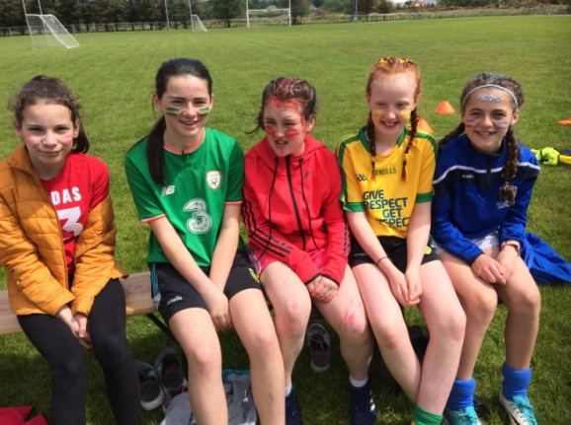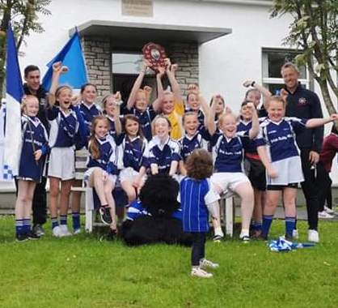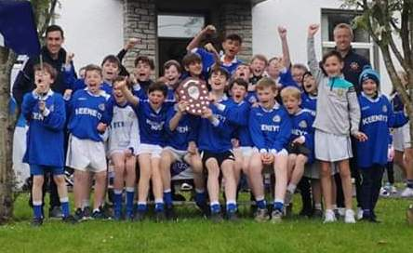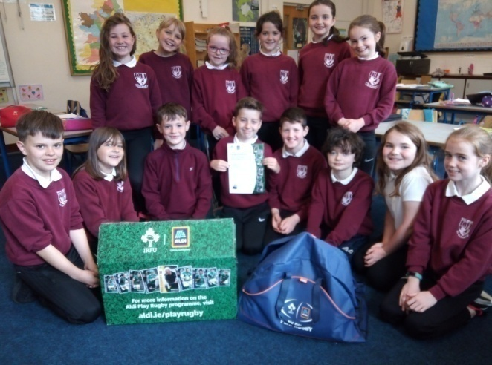

**Enjoying Sports Day 2019**

**Cumann na mBunscol Champions**

It has been a historic year for the Scoil Mhuire Gaelic football teams as both the boys and girls won the Cumann na mBunscol County titles in June. The girls had victories over Rannafast, Crannog Buí and Gortnacart in their regional blitz before defeating St. Connell’s in a close game in the next round in Ardara. They overcame Stramore in the county quarter-final in Glenfin and won a tough match against Dunkineely in the semi-final in Donegal Town. In the final in O’ Donnell Park the girls defeated Gleneely to record a remarkable double as they also won the Indoor Gaelic title earlier in the year. The boys also came through their regional blitz against Gortnacart, Crannog Buí and a very close encounter with Rannafast in which they required two late goals to progress. They also defeated St. Connell’s in the next round and beat Glenfin in the quarter-final. The boys had to dig deep against a strong Ballintra side to reach the final where they produced a marvellous display of skill to beat Cloontagh. Both sets of players can be very proud of their efforts and displays for the school this year! Congratulations to everyone involved!

**Rugby**

Thank you to everyone who collected and sent in Aldi stickers for a recent competition which the school entered. We didn’t receive the big cash prize but we did receive a sports pack which consisted of rugby balls and sports bottles. Thank you!

**GAA 5 Star Centre**

This year, Scoil Mhuire received a GAA flag and became a GAA 5 Star Centre. We achieved this by undertaking a number of GAA based activities throughout the year. When we return to school in September we will be having a flag-raising celebration which we are all looking forward to!

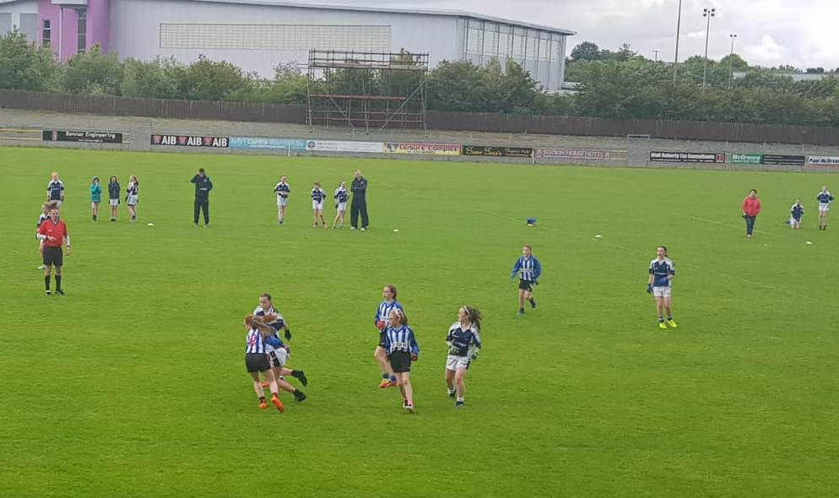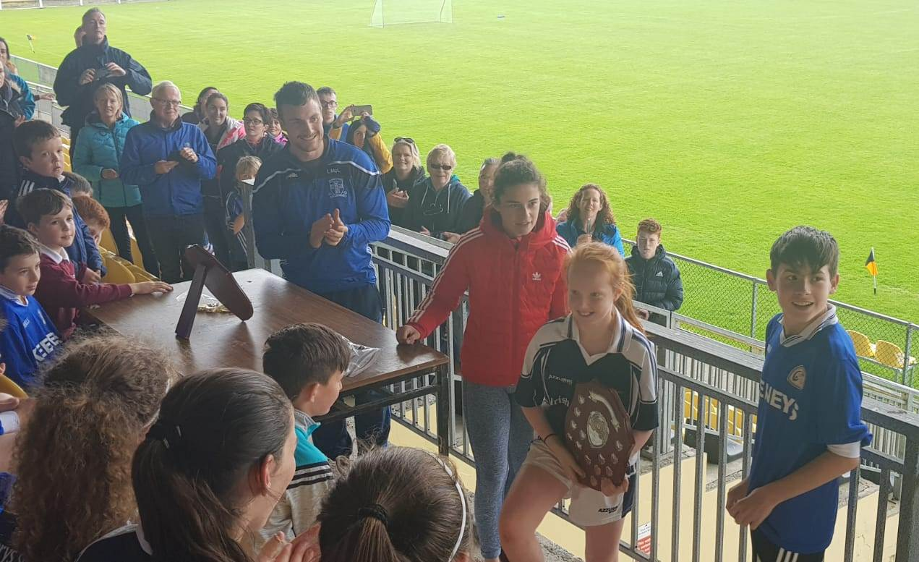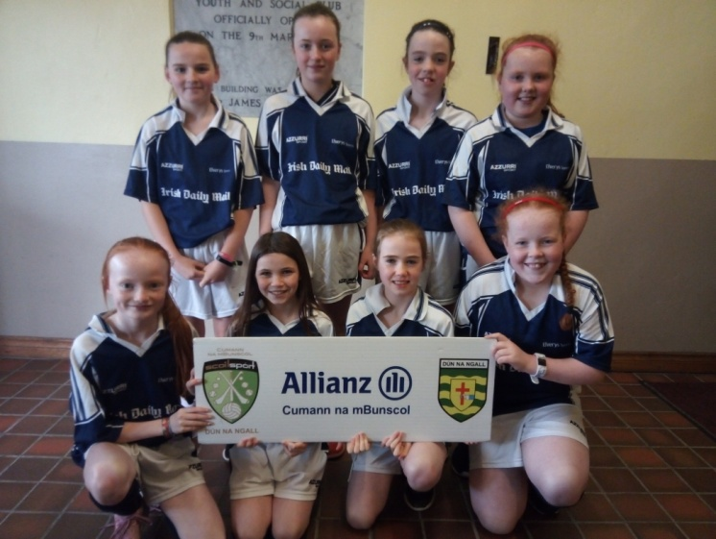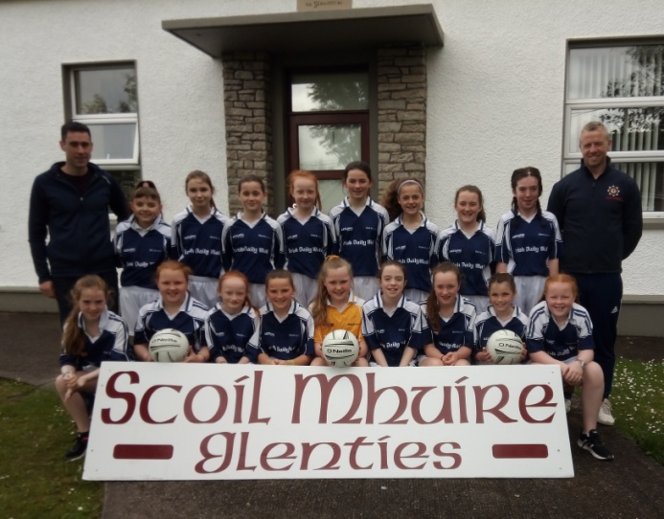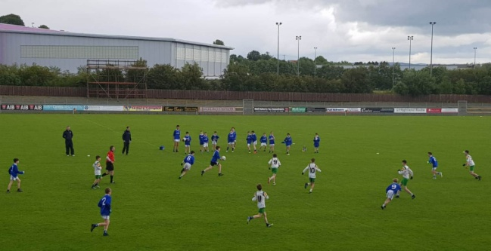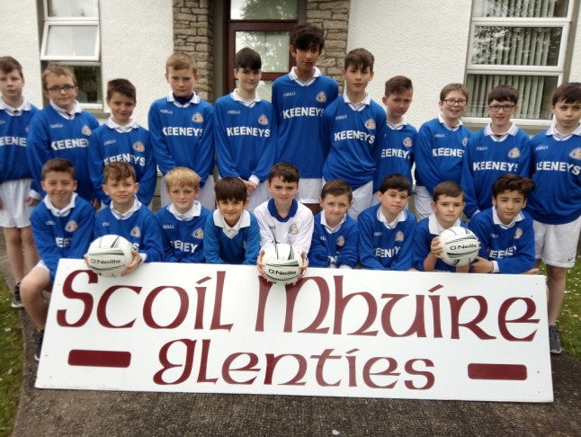

**Scoil Mhuire, Glenties**

**Cumann na mBunscol ‘Treble Winners’ 2018/2019**

Girls Indoor Gaelic

Girls Outdoor Gaelic

Boys Outdoor Gaelic