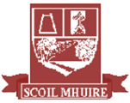

**Scoil Mhuire**

**Newsletter Summer 2018**



**It’s hard to believe we have arrived at the end of what has been another busy school year!**

During the last term we had a Whole-School Evaluation and I would like to thank the staff, pupils, families, Board of Management, Parents’ Association and the entire school community for your help and input to the evaluation.

Special mention this year must go to the school’s girls Gaelic team who won the Cumann na mBunscol County title for the first time since 2013. Congratulations girls on a remarkable campaign!

Congratulations also to 2nd Class on making their Holy Communion and to Ms Boyle and Ms Gavigan for preparing them so well. Special thanks to Fr. Gerard for the spiritual guidance he provided the children throughout the year.

I would like to thank the 6th Class boys and girls for the happy memories they provided us during their time in Scoil Mhuire and wish them all the best as they move on to secondary school. Remember to call back to visit us at any stage!

I hope you all have a safe and enjoyable summer and we look forward to seeing you all in September again!

Maria Stewart (Acting Principal)

**Glenties**

In this newsletter:

* Cumann na mBunscol Champions
* History Project Winners
* Children’s Poetry
* Active Schools Week
* Nature Studies
* Farm Visit
* Yearly Planner
* Board of Management End of Year Report
* Sports
* Farewell to 6th Class

...and much, much more!

**Cumann na mBunscol County Champions!**

Pride of place in Scoil Mhuire this year goes to the girls who won the Allianz Cumann na mBunscol Gaelic title. The girls had victories against St. Connell’s Portnoo, St. Naul’s, Gleneely and Dunkineely to reach the county final which was played on 24th May. The girls had to go to extra-time to defeat Glenmakee in a pulsating game of football. The panel of players was Cathy Browne, Emma McDevitt, Erin Doherty, Niamh McGeehan Bonner, Cora Doherty, Abbie Bonner Diver, Lara Lynch, Orla Molloy, Eve Boyle Carr, Annie Brennan, Shauna Molloy, and Charlotte Quigley. Congratulations girls on a massive achievement!

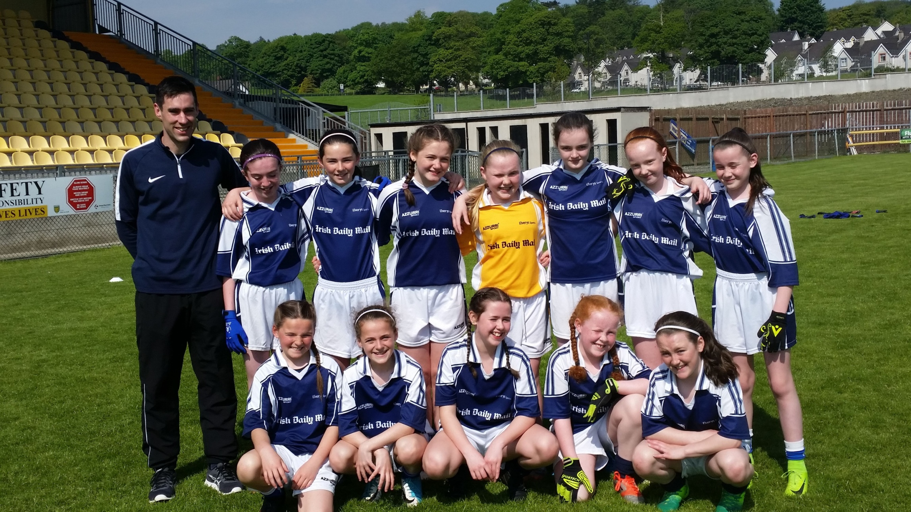

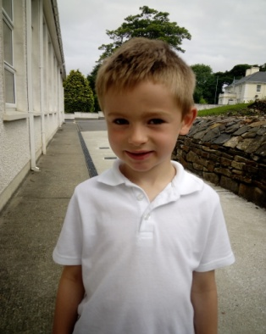

**Welcome to Scoil Mhuire**

A big, warm welcome

to Jayden Spratt

who joined the Senior

Infants class during

the year! We hope

you have a wonderful

time in Scoil Mhuire!

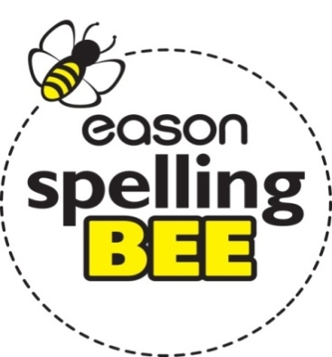

**Eason Spelling Bee**

Congratulations to Erica Hegarty who won the Scoil Mhuire Spelling Bee for the second year in a row! The competition took place between all 5th and 6th Class pupils and it proved a very tense afternoon with a very high standard of spellings. There were some very difficult words such as ‘abseil’, ‘broccoli’, ‘omnium’, ‘factitious’ and ‘guacamole’. Erica held her nerve and answered all words correctly and represented the school at the Spelling Bee County Final in Letterkenny in May. Well done Erica!

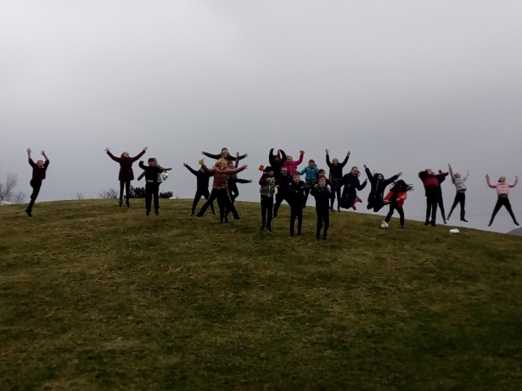

**River Studies**

The 3rd and 4th Classes had an exciting day exploring the Owenea River and its surrounding habitats in April. They visited the Mullantiboyle Bridge and took water and kick samples of the river to test its cleanliness and investigate the different bug species living in the river. Their results unfortunately showed the river was slightly polluted.

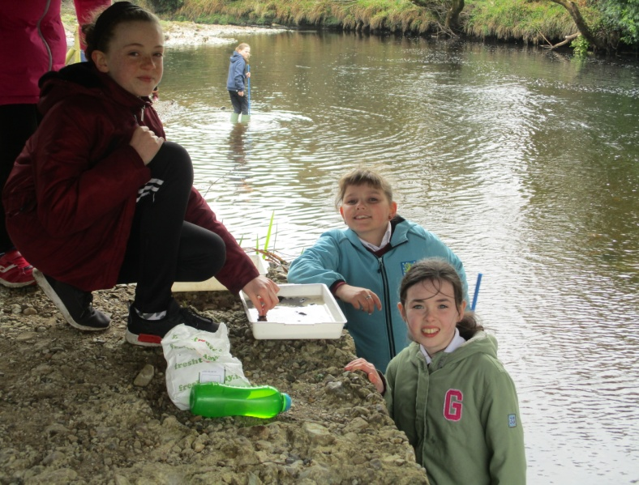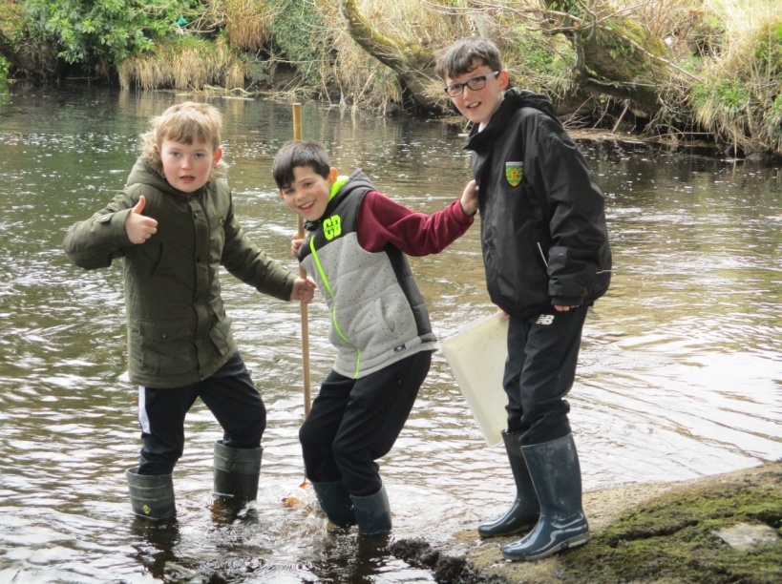

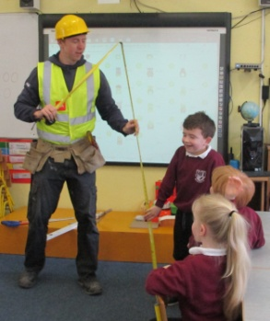

**Coding**

During April and May Oliver Stanislawczky visited the 3rd to 6th Class children to teach us coding. We’re learned how to use block code and at the end of each hour of coding we got to edit our own game using what we learned. We really enjoy it!  A big thank you to Oliver who volunteered his time to teach us this important skill for the future!

By Kian Kennedy

**Hard Hats**

Many thanks to Stephen McDermott who visited the Junior and Senior Infant classes in May and taught us everything about the construction trade. The children got to check out some of the builder’s equipment and Stephen was impressed with some of the handy work produced by our busy workers!

**Tweet Tweet!**

The 3rd and 4th Classes learned about some of our migratory birds in Spring and identified them by their call sounds. They spotted some woodland birds such as

the jay and goldcrest

while on a nature walk

down the Tullyard Road.

Upon returning to the

classroom they made

sponge on card ‘Bird in

Nest’ art constructions

using wool, hay, grass,

rushes, twigs, lichen

and moss.

**Garda Visit**

Thank you to Gardaí Emmet Cassidy and Pauline Shovelin who visited the school in May and taught us all about the importance of being safe on the roads, safe online and safe in our community. We even got to check out the Garda patrol car and its equipment!

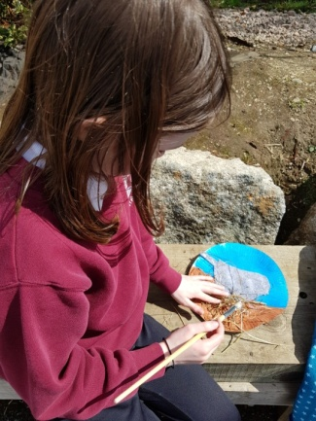

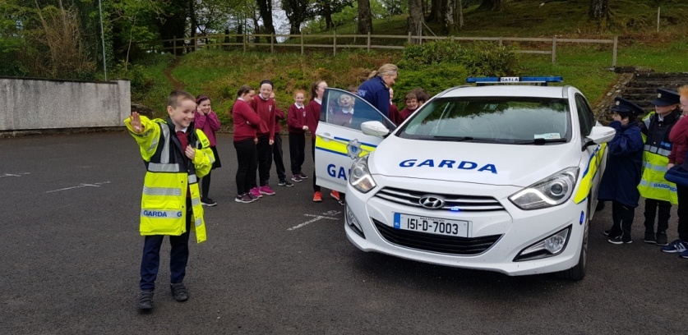



**Spring**

Spring is here. Baby animals are born in spring. I love spring because of the baby animals that are born. Baby frogs are born. When they’re born they’re called a tadpole. Then they turn to frogs. Baby birds are in their eggs in their nest. Baby lambs are born in the shed with hay.

By Sofia McGettigan Deane (Senior Infants)

**First Holy Communions**

2nd class made their First Holy Communion on Saturday 12th May. They prepared for this special day by making their first confession in April. The boys and girls received Jesus for the very first time and they all had a wonderful day with their families and friends. They looked fantastic and did their jobs so well during the Mass. Congratulations to all of 2nd class!

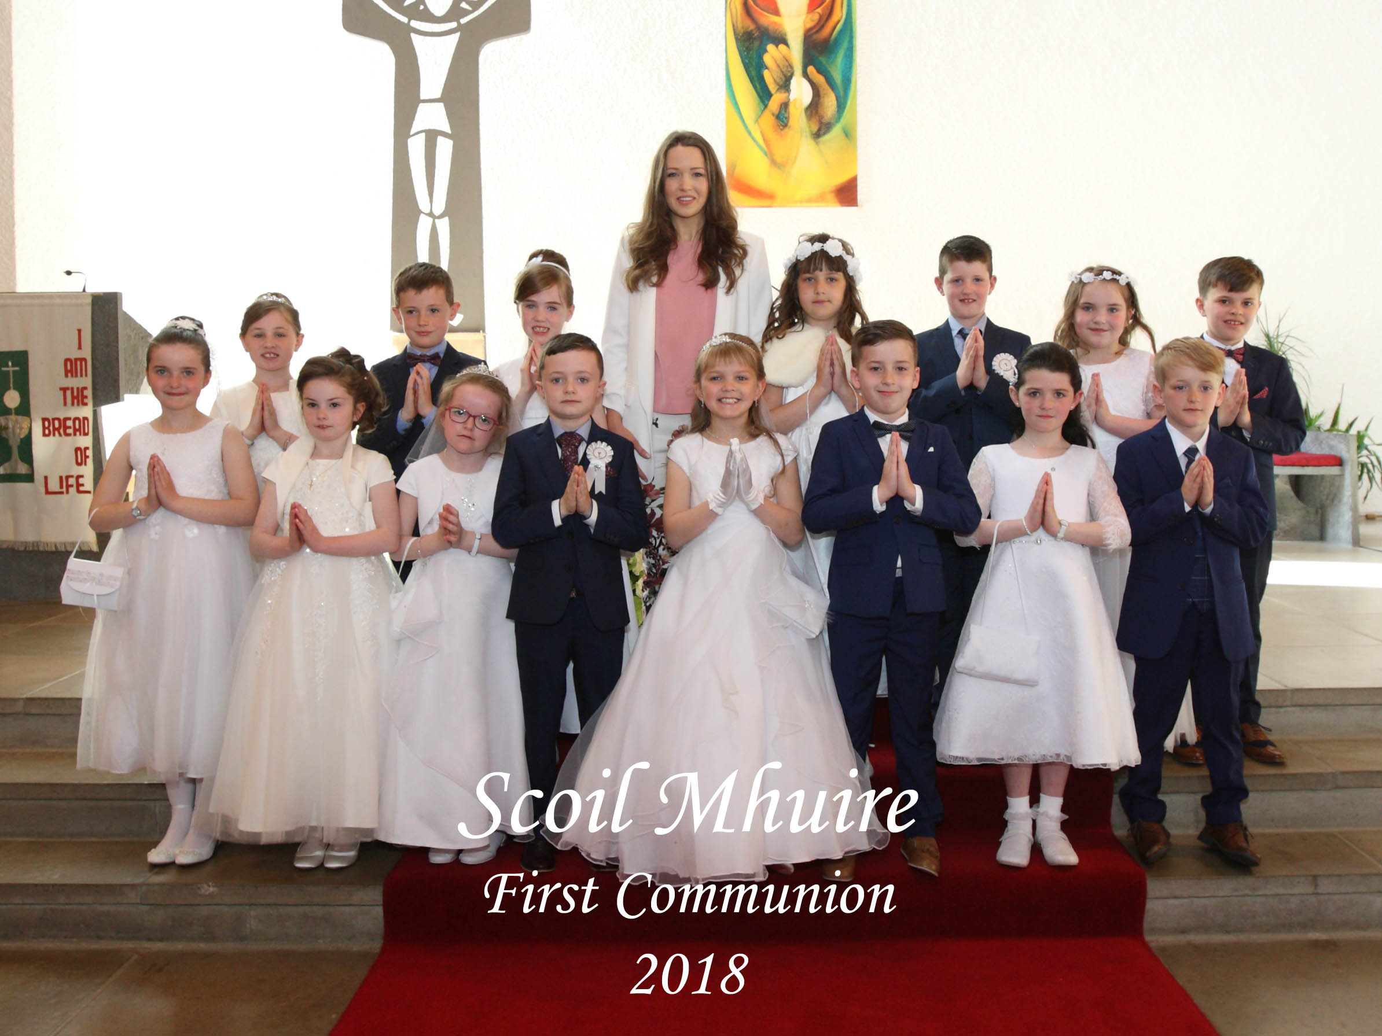

**Book Fair**

The Book Fair visited the school for a week in May and it proved a busy attraction for the week! Boys and girls rushed to get their hands on new releases as well as old favourites and have been enjoying their books since! A special thank you to the boys and girls in 6th Class who acted as cashiers at the cash register for the week!

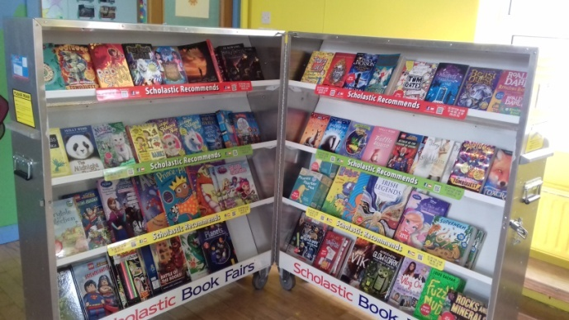

**Donegal Historical Society**

Congratulations to the 5th Class who were awarded 1st prize in the Donegal Historical Society Schools Competition. The competition’s theme was ‘Links between Donegal and Europe before the 1900s’ and the class compiled a local history project studying artefacts, monuments and people from the area of Glenties. We went all the way back to the Stone Age and compiled the project chronologically from then up to when the railway came to Glenties in 1895. We spent a lot of time researching in St. Connell’s museum, reading information in books, interviewing people and taking trips to local sites such as St. Connell’s bell and Kilclooney portal tomb. We researched things such as megalithic tombs, lunulae, St. Conall, the woolen industry in the area and the railway station in Glenties

           Ms. Eleanor thought it would be a good idea to visit some of the places we learned about so on May 27th we went on a trip! As we had learned that St. Conall brought Christianity to this part of Donegal we visited Inishkeel Island, off Narin beach, where he had lived for some time. We visited St. Conall’s Church and St. Mary’s Church and examined all the crosses and headstones. We also visited the dolmen in Kilclooney and the replica of the lunula that was found in Rosbeg in the Dolmen Centre. We had lots of fun and thanks to Lochlann Mc Gill for coming with us and for telling us interesting facts. At a presentation back at school the president of the society presented us with a trophy and our prize.

By Anton Campbell

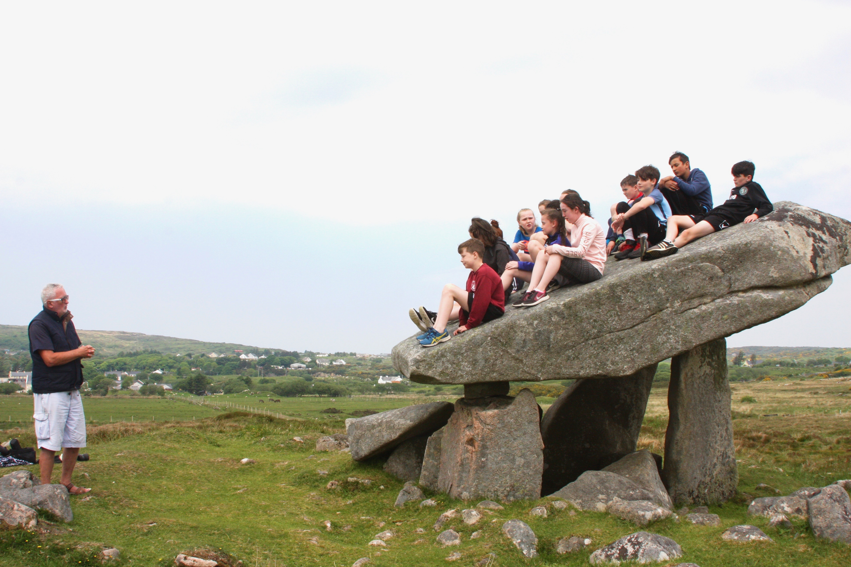

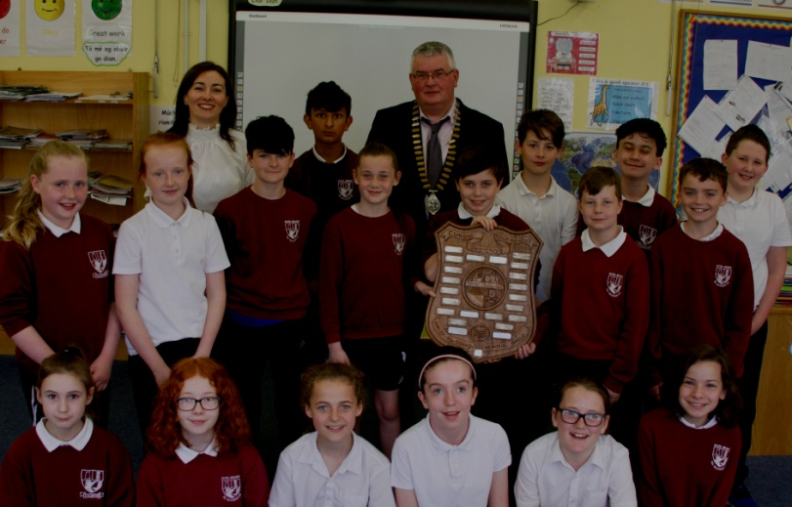

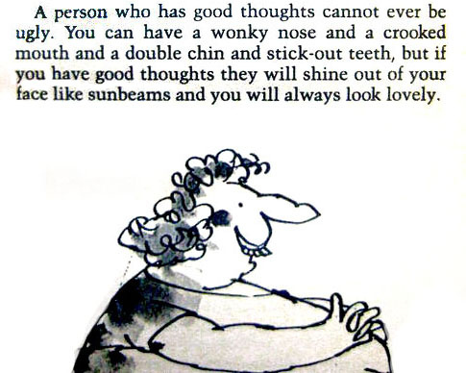

**Grass Heads!**

The 5th class started making grassheads at the start of May. It was a really fun experience learning how to make them with Ms Eleanor. Firstly, we filled soil and seeds into tights. We then watered them and fitted them into a pot before we replaced the pot with a jam jar. We then decorated the grassheads and the jam jar. If you want to see them they are on display at the front of the school and are growing every day. They will soon require a hair cut!

By Danny Brown and Conan Brannigan

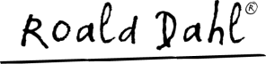

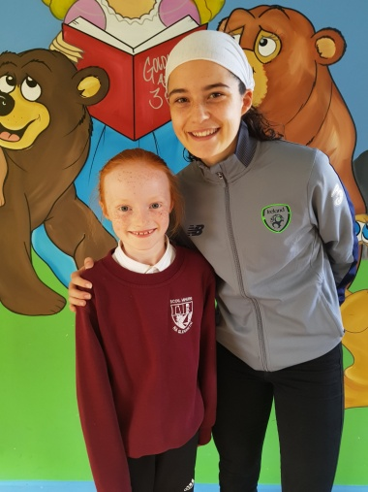

**Active Schools Week**

Scoil Mhuire held a very successful Active Schools Week from 23rd to 27th April. We did GAA, soccer, basketball and athletics to name but a few of the activities. On Friday we had our Active Schools Week assembly where we were joined by our special guest Amy Boyle Carr. A drawing competition and activity based puzzles were held in conjunction with the week and the winners were Alicia Bonner, Lilliane Becht, Rebecca Quigley, Bethany Gilroy, Emma McDevitt, Katie Doherty, Yanna McHugh, Ailbhe Doherty, Riaghan Doherty, Conan Brannigan and Sophia Gildea Molloy. We also announced the winner of the spring newsletter competition at the assembly. Last year’s winner was Eoghan Quinn and you will not believe it but this year’s winner was Eoghan Quinn again! We had lots of fun at Active Schools Week!

By Conor Farrell

**Say Yes to the Dress Fundraiser**

Scoil Mhuire Parents’ Association hosted a ‘Say Yes to the Dress’ Fundraiser in the Highlands Hotel on the 27th of April. We would like to thank the Parents’ Association for organising the event in which over €3000 was raised. Thank you to everyone who contributed in any way to a very successful night!

By Shauna Molloy & Ailbhe Doherty

**The School Alphabet**

A is for Active Schools Week where we play fun sports

B is for basketball lessons with Aoife and recently Dave

C is for classrooms where we do all our work  
E is for earning points and rewards  
F is fun and friends, two awesome things  
G is for generosity that we show all day  
H is for helping others when they fall or if they are sad  
I is for imagination, used at every turn!  
J is for jiving... Oh that is great fun!  
K is for kindness that we show  
L is for learning cool new things every day  
M is for maths that helps us learn sums  
N is for Newsflash! That is really awesome  
O is for other subjects that we enjoy to learn  
P is for Primary Planet, a news magazine  
Q is for the questions we’ve asked throughout the year  
R is for running when playing games  
S is for Sports Day where we compete in competitions  
T is for teamwork when we play with our friends  
U is for understanding the things our teachers say  
V is for very nice manners that we all have to show

W is for working hard all day long  
X is for e**x**cellent work that we do  
Y is for your healthy lunches that keep you fit!  
Z is for ZZANK YOU! For reading this poem! ☺

By Áine Brannigan and Erin Bonner from 4th Class



**Friends for Life**

This year the 5th and 6th Classes started the Friends For Life programme with Ms. Bonner. We learned to think positive thoughts and the programme has helped us to be more confident and brave.

By Cathy Browne and Lara Lynch

A couple of things to remember:

School website is [www.scoilmhuireglenties.com](http://www.scoilmhuireglenties.com)

The school will close for 2018 summer holidays on Friday 22nd June at 12.30pm.

**School Closures 2018/2019:**

**School will re-open on Wednesday 29th August**

Closed Wednesday 12th September – Harvest Fair Day

**Mid – Term Break (Halloween)**

Closing on Friday 26th October / Re-opening on Monday 05th November.

**Christmas Break**

Closing on Friday 21st December / Re-opening on Monday 07th January.

**Spring Mid-Term Break (February)**

Closing on 15th February / re-opening Monday 25th February

**Easter Break**

Closing on Friday 12th April / Re-opening Monday 29th April.

**Other Closures**

Closed on Monday 18th March (Bank Holiday)

Closed on Monday 6th May (Bank Holiday)

Closed on Monday 03rd June (Bank Holiday)

**Summer Holidays**

School will close on Thursday 27th June 2019



**Board of Management End of Year Report:**

* The Board of Management manages the school on behalf of the patron and is accountable to the patron and the Minister. The Board must uphold the characteristic spirit (ethos) of the school and is accountable to the patron for so doing.
* Board of Management positions are as follows:
* Chairperson: Harry Reid (Patron nominee)
* Patron Nominee: Fr. Gerard Cunningham
* Community Representative: Eileen McDyer (Safety Officer)
* Community Representative: Francis Brennan
* Principal (Acting): Maria Stewart (Secretary)
* Staff Representative: Eleanor McGill
* Parent Representative: Patricia Molloy (Treasurer)
* Parent Representative: Joe Gavigan (Capital Projects)
* School policies are available to view on the school website and a hard copy is available from the secretary. Review dates are on the policies and all parents are welcome to contribute to the review.
* The Board of Management acknowledges the recent Whole-School Evaluation - Management, Leadership and Learning which the school received a very good report from. The report and recommendations are available from the departmental website.

**1st & 2nd Class Nature Trail**

Aengus Kennedy from Heritage in Schools came to 1st and 2nd Class in April and we went out to explore the nature on our doorstep. We learned about the parts of a flower and how they attract insects and bees with their bright petals and tasty nectar. We even saw a queen bee! We listened to birds singing, we made our own nature booklets, mouse houses and spring crowns. We had a great day!

**Spring**

**S**un shining in the sky

**P**etals are popping out

**R**abbits are hopping around

**I**ce cream vans appear

**N**ests are being built

**G**rass is growing in the fields

By Joseph Browne (1st Class)

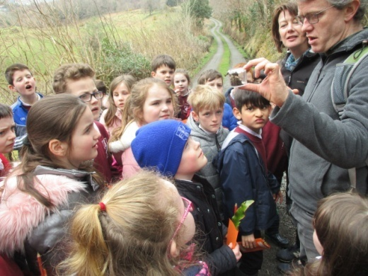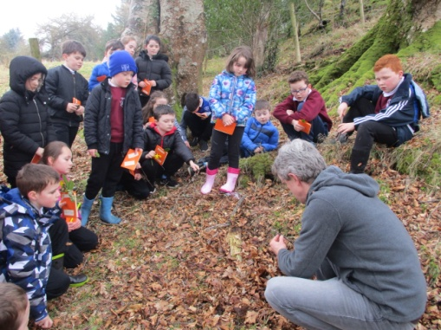

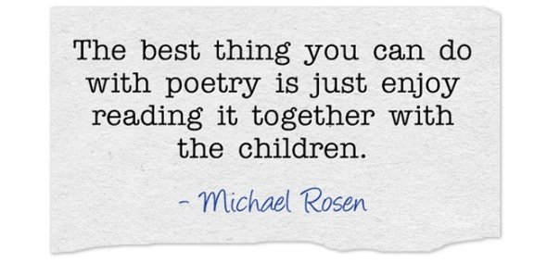

**School Tour**

1st and 2nd class went to Castle Adventure Open Farm in Ballyshannon for their school tour. They got to see lots of interesting animals including an Alpaca. They petted a rabbit and fed a baby goat which is called a kid. They all got to operate real diggers and had loads of fun playing! It was farm-tastic!!

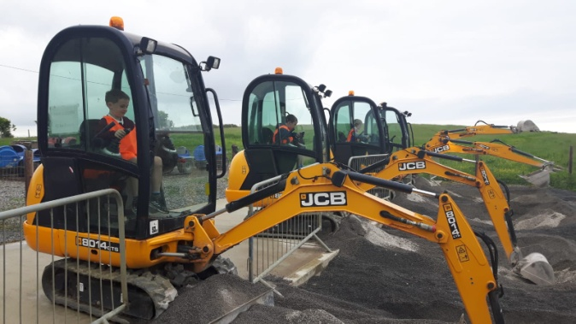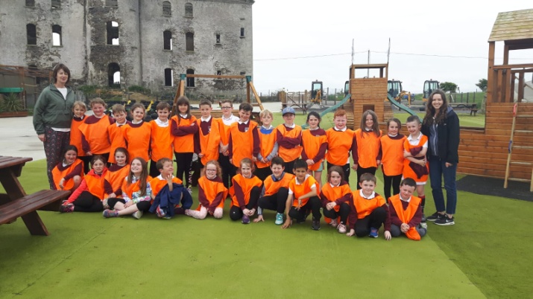

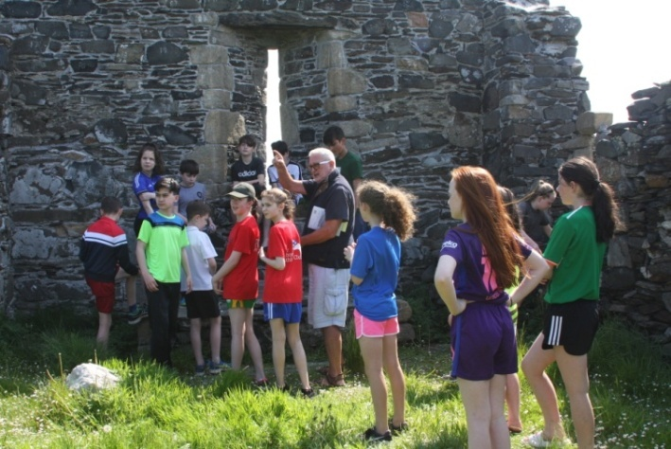

The 5th Class enjoying a visit exploring Inishkeel Island earlier this year

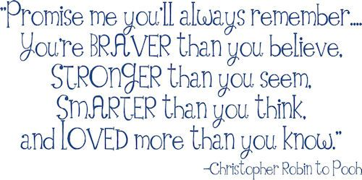

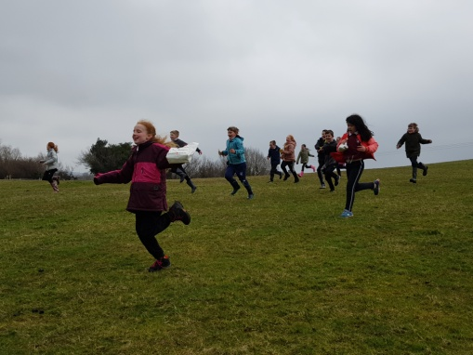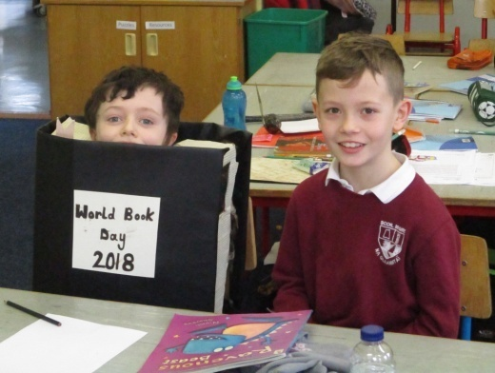

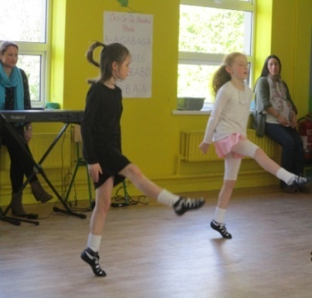

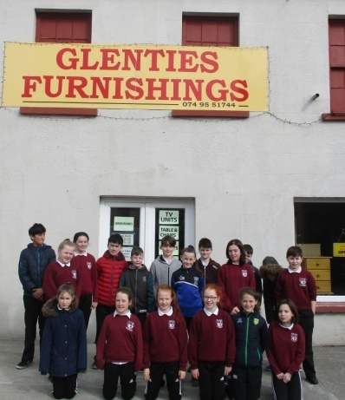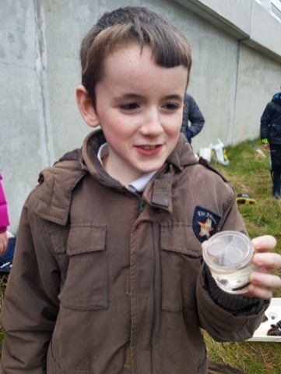

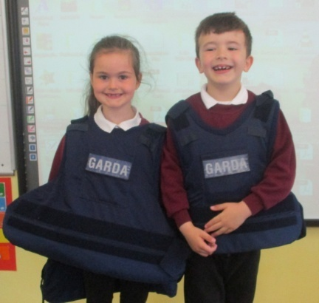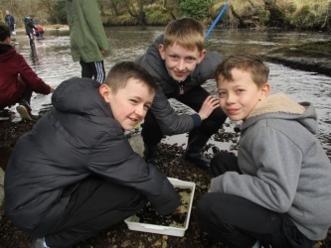

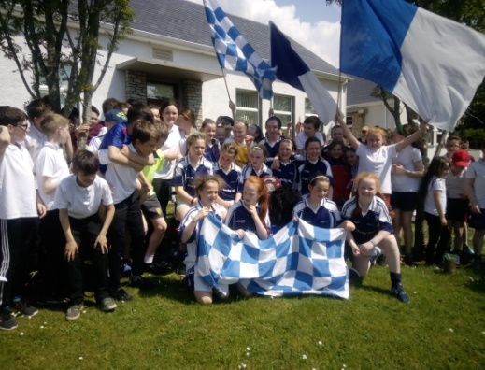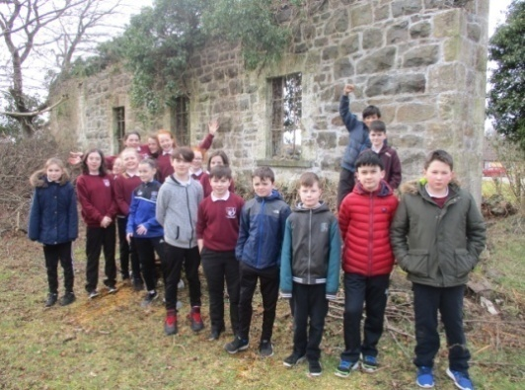

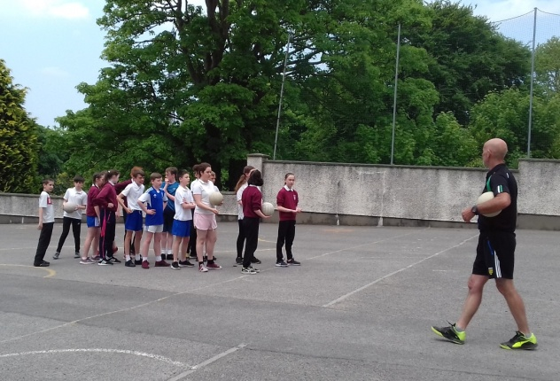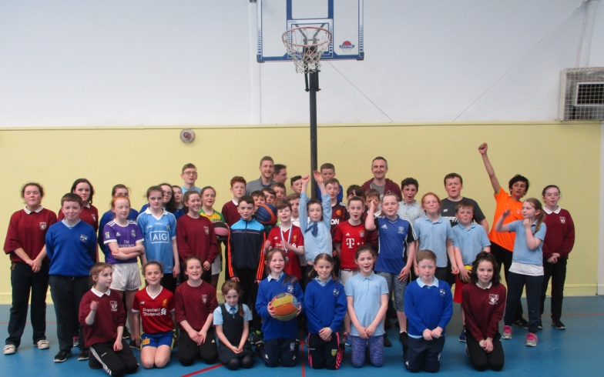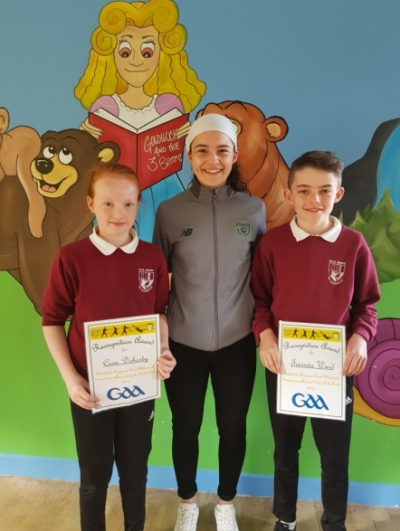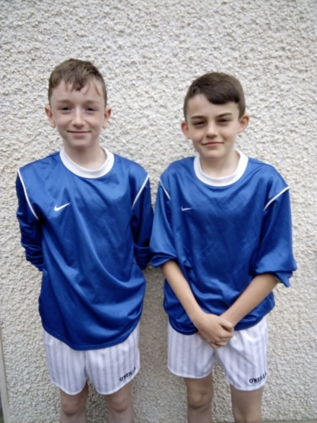

**Swimming**

Well done to all the 5th and 6th Class pupils who completed eight weeks of swimming lessons in the Finn Valley Centre. This is a vital life skill to have and an enjoyable exercise and way of keeping fit!

**Gaelic Football Coaching**

A big thank you to Donie McCole who has been visiting the school every Monday since Easter to coach us the skills of Gaelic football. The boys and girls have learned so much and have made fantastic progress this year!

**Basketball**

Throughout April and May the boys and girls in Scoil Mhuire have been receiving basketball coaching from David Tierney and we have been thoroughly enjoying the activity. We’ve been taught multiple moves and tactics to improve our skills. It’s been great fun for everyone and we are so grateful to the coaches and instructors who taught us (David, Niall, Paul and John.) After a few weeks of practicing, we all got the hang of the sport and organised a tournament with St. Riaghan’s NS, Drimnacrosh. A special well done to both Anton Campbell and Eve Boyle Carr in 5th Class who won the ‘hot seat’ competition we played!

By Tierna Brannigan

**Soccer**

Well done to the boys and girls who competed in the Fran Fields soccer competition on the 17th May. The tournament was held in Killygordan and involved four matches against St. Mary’s Stranorlar, St. Eunan’s, Ramelton and Dooish. Both our boys and girls teams finished runners-up after a fantastic day of football in the glorious sunshine!

**Gaelic Football Achievements**

Congratulations to Tiarnán Ward who was one of only four players in the county to be selected to play at half-time of this year’s Ulster Football Final at the end of June. Tiarnán was selected after a tough assessment trial in Glenswilly in May. Cora Doherty also represented the school at the trials and performed impressively! Well done also to Oran Doherty who was chosen to play at half-time of the Donegal-Cavan Ulster Championship match at MacCumhaill Park in May. This is a huge honour for these players and everyone in Scoil Mhuire is so proud of you!

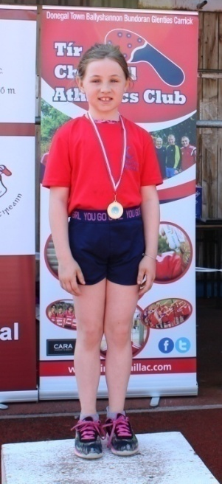

**Athletics**

Congratulations to all the boys and girls from Scoil Mhuire who performed impressively at the annual Primary School Athletics which was held in the Abbey Vocational School, Donegal Town at the end of May. The event was organised by the Tír Chonaill Athletics Club which a number of our pupils attend. From our school Marc Gavigan, Karolina Byrne, Áine Brannigan, Erin Bonner, Ailbhe Doherty, Emily Cunnea Melly, Éabha Molloy and Saoirse McDermott all competed with a host of medals returning to the school! Emily came first in her sprint while Áine finished in second place! In the long jump Eabha and Saoirse both finished joint third with a fabulous jump of 2.4 metres! Saoirse also finished second in the turbo. In the relay race, the Scoil Mhuire team of Áine, Karolina, Ailbhe and Erin finished in third place. What a performance from our athletes! Well done, guys!

**Cumann na mBunscol**

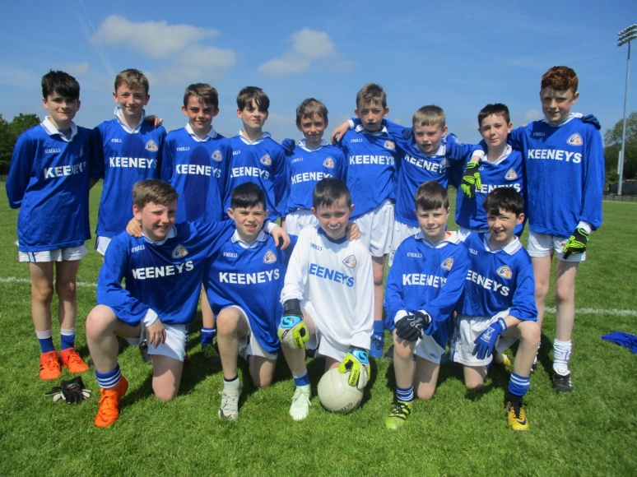

The boys had a very successful run in the Cumann na mBunscol Gaelic football competition this year, reaching the semi-final stages of the competition. The boys had impressive victories against St. Connell’s Portnoo, Gortnacart, Crannog Buí and Drumkeen to reach the semi-final of the competition. They were defeated by Kilcar in the semi-final despite playing some fine football. This was a remarkable run for these lads who produced some amazing fightbacks in numerous matches throughout the season.

**Farewell**

It’s come to the sad time again where we must say farewell to a wonderful bunch of boys and girls who are leaving Scoil Mhuire. They have been a fun, hard-working group and have been fantastic role models and helpers to the younger children in the school and we’ll all miss them dearly! Everyone in Scoil Mhuire wishes them all the very best of luck in secondary school and in the future!

